IP Address
An IP address (Internet Protocol address) is a unique numerical identifier assigned to each device connected to a network. It allows devices such as computers, smartphones, servers, and IoT devices to identify each other and communicate over the Internet or a local network. Every data packet sent across a network contains both the source and destination IP addresses to ensure correct delivery.
An IP Address (Internet Protocol Address) is a unique numerical label assigned to each device connected to a computer network that uses the Internet Protocol for communication. It serves two main purposes:
- Identifying a device on the network.
- Locating the device to enable communication with other devices over a network like the Internet.
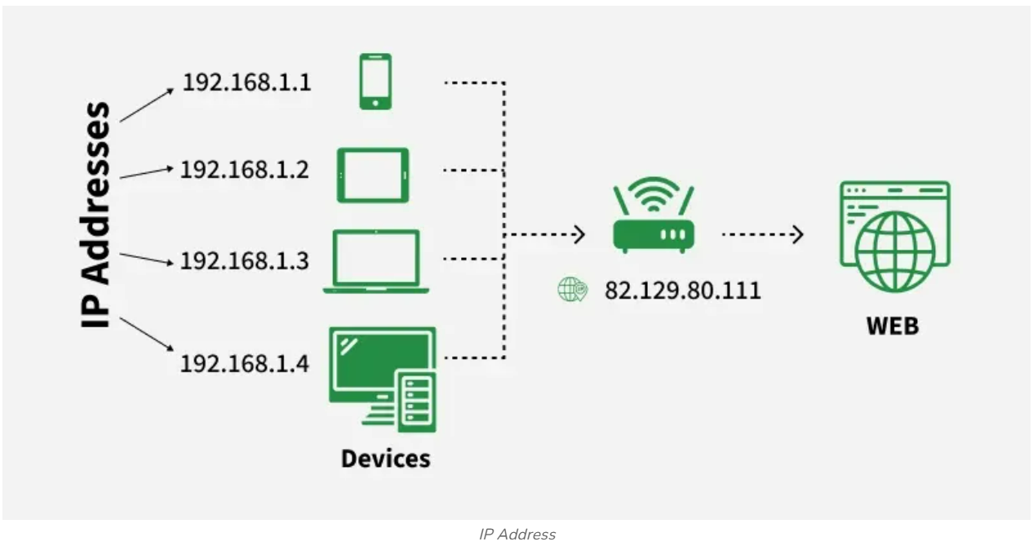
Note: In simple terms, an IP address acts like a digital home address, allowing data to be sent and received between devices correctly.

Types of IP Address
IP addresses can be classified in several ways based on their structure, purpose, and the type of network they are used in. Here's a breakdown of the different classifications of IP addresses:
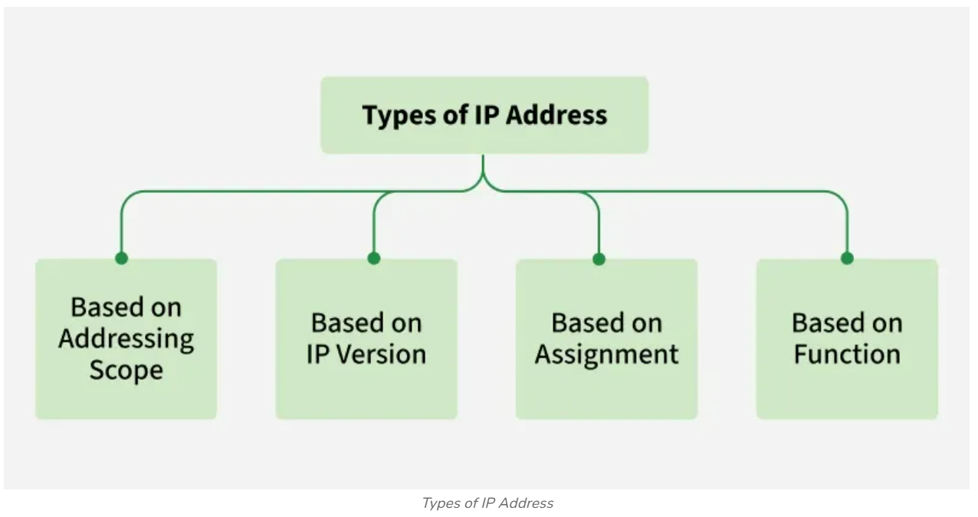
- Based on Addressing Scope
Public IP Addresses
A Public IP address is assigned to every device that directly accesses the internet. This address is unique across the entire internet. Uniqueness & Accessibility are its key characteristics & are assigned by Internet Service Providers. Public IP addresses are typically assigned by an Internet Service Provider (ISP). When you connect to the internet through an ISP, your device or router receives a public IP address. These addresses can be static or dynamic.
Public IP addresses are internet routable. In Google Cloud, external IPv4 and IPv6 addresses are always public IP addresses.
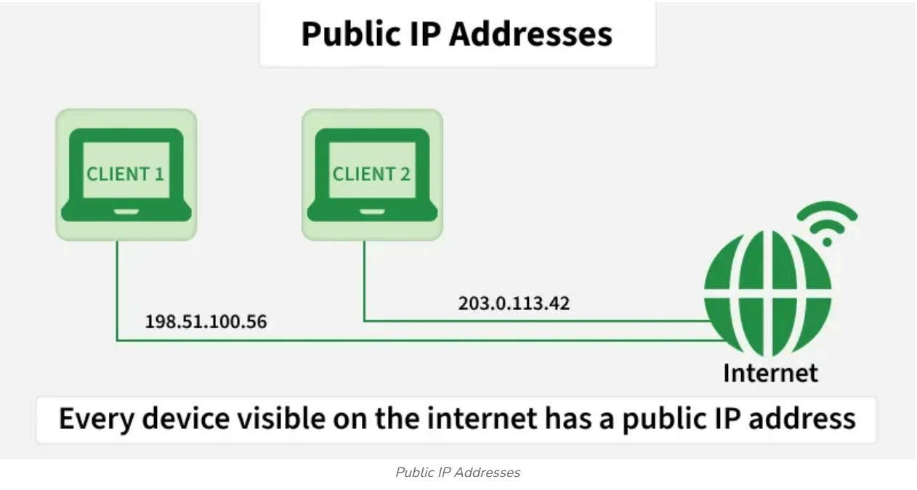
Example Use: If you host a website on your own server at home, your ISP must assign a public IP address to your server so users around the world can access your site.

Private IP Addresses
Private IP addresses are used within private networks and are not routable on the internet. This means that devices with private IP addresses cannot directly communicate with devices on the internet without a translating mechanism like a router performing Network Address Translation (NAT). These are only required to be unique within their own network & are used for communication between devices within the same network
- Defined ranges for IPv4: 10.0.0.0 to 10.255.255.255, 172.16.0.0 to 172.31.255.255, 192.168.0.0 to 192.168.255.255
- Defined ranges for IPv6: Addresses starting with FD or FC
Example Use: In a typical home network, the router assigns private IP addresses to each device (like smartphones, laptops, smart TVs) from the reserved ranges. These devices use their private IPs to communicate with each other and with the router. The router uses NAT to allow these devices to access the internet using its public IP address.
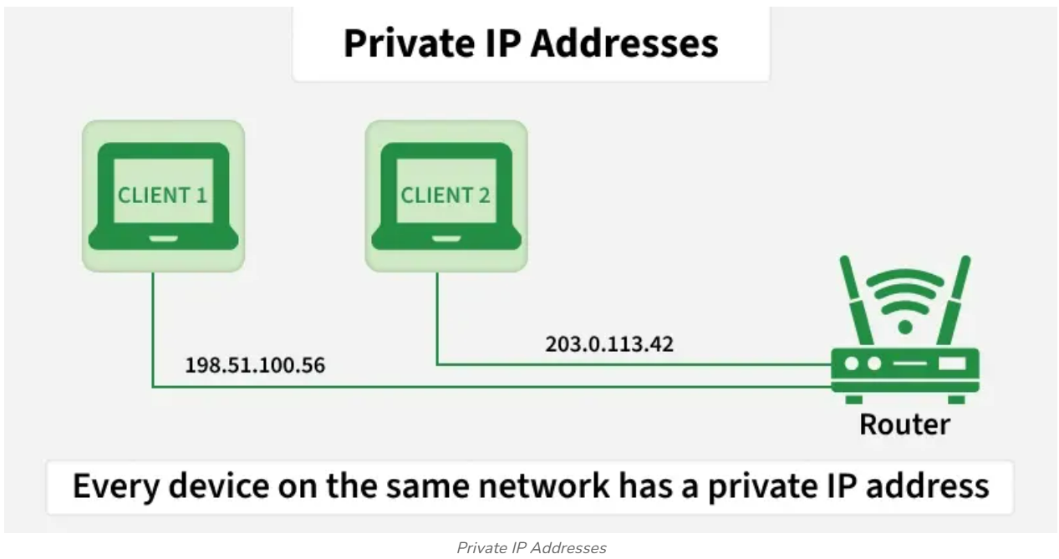
Private Vs Public IP Addresses
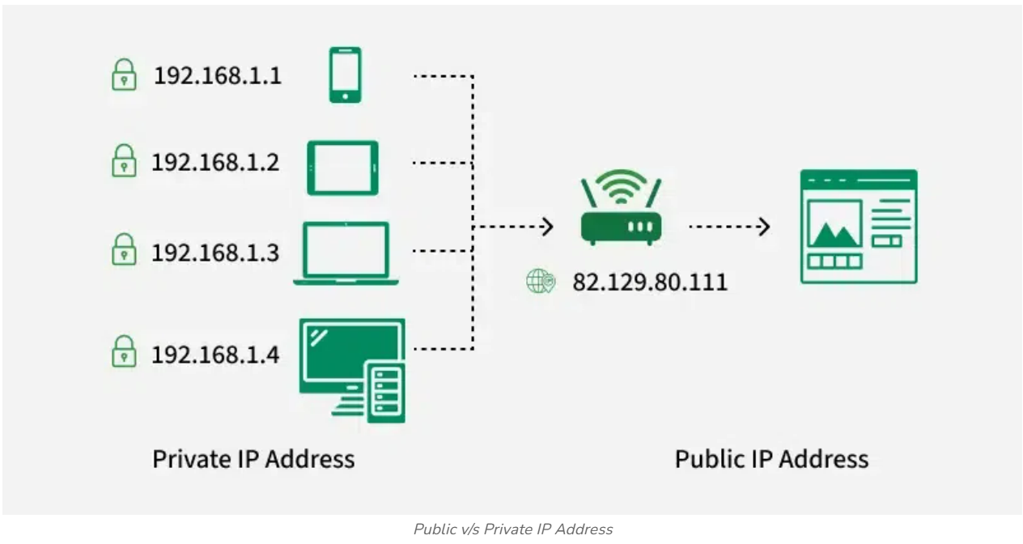
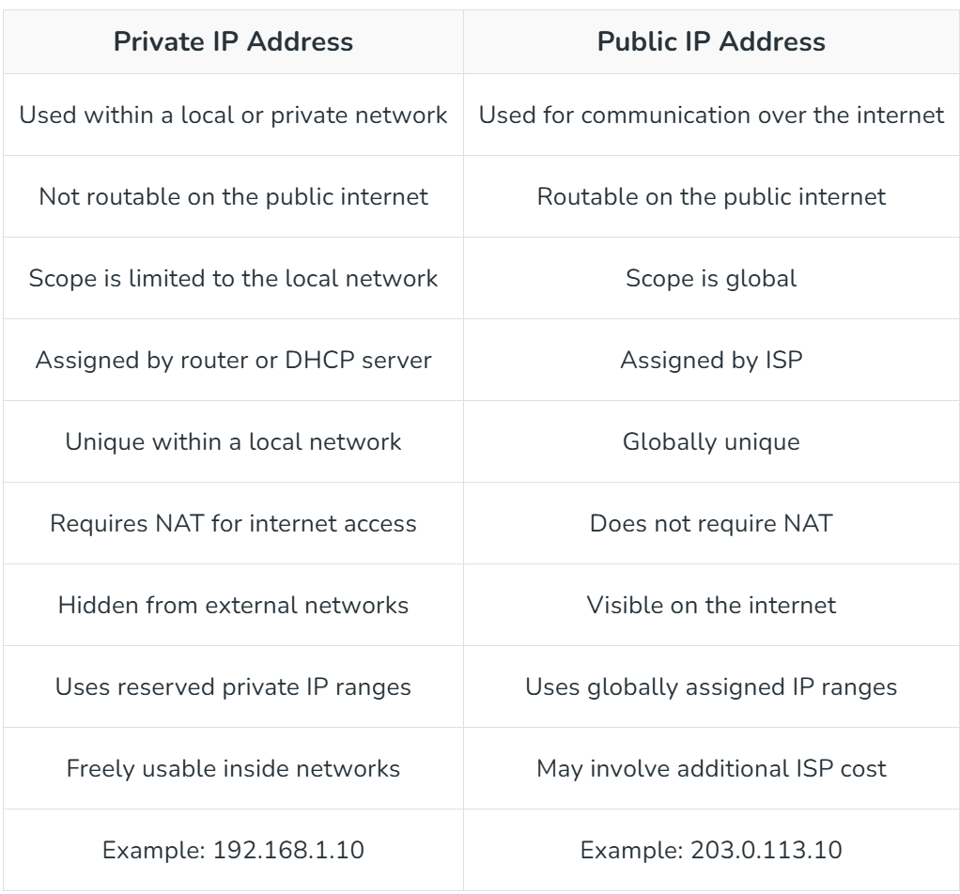

- Based on IP Version
IPv4
This is the most common form of IP Address. It consists of four sets of numbers(octets) separated by dots. This format can support over 4 billion unique addresses. Each octet represents eight bits, or a byte, and can take a value from 0 to 255. This range is derived from the possible combinations of eight bits (2⁸ = 256 combinations).
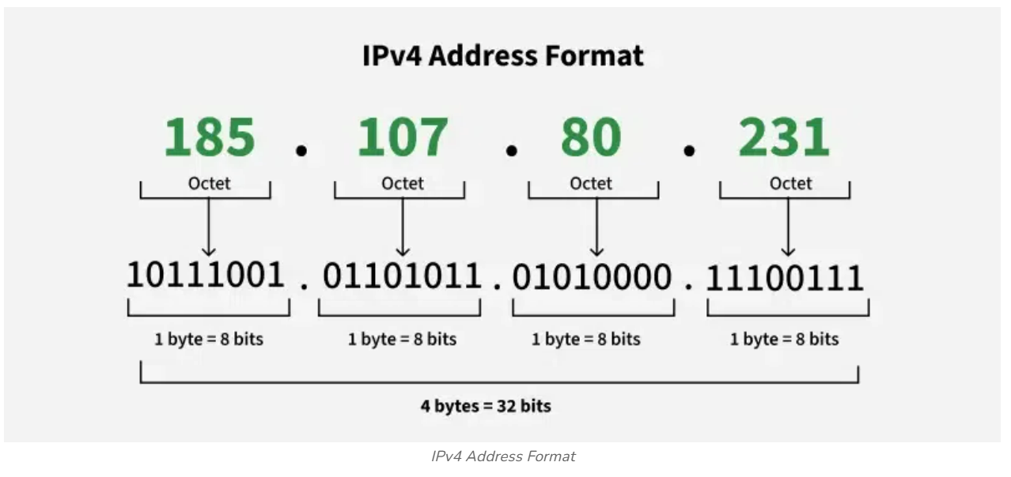
IPv4 Address Format
Example of IPv4 Address: 192.168.1.
- 192 is the first octet
- 168 is the second octet
- 1 is the third octet
- 1 is the fourth octet
Structure of an IP Address (IPv4)
An IPv4 address is a 32-bit number, usually written in "Dotted Decimal" format. It consists of four numbers (octets) ranging from 0 to 255, separated by dots.
Example: 192.168.1.15
The address is split into two logical parts. The split depends on the Class or Subnet Mask:
- Network ID: Identifies the "Street" (The network the device belongs to).
- Host ID: Identifies the "House Number" (The specific device on that network).

IPv6:
IPv6 addresses were created to deal with the shortage of IPv4 addresses. They use 128 bits instead of 32, offering a vastly greater number of possible addresses. These addresses are expressed as eight groups of four hexadecimal digits, each group representing 16 bits. The groups are separated by colons.

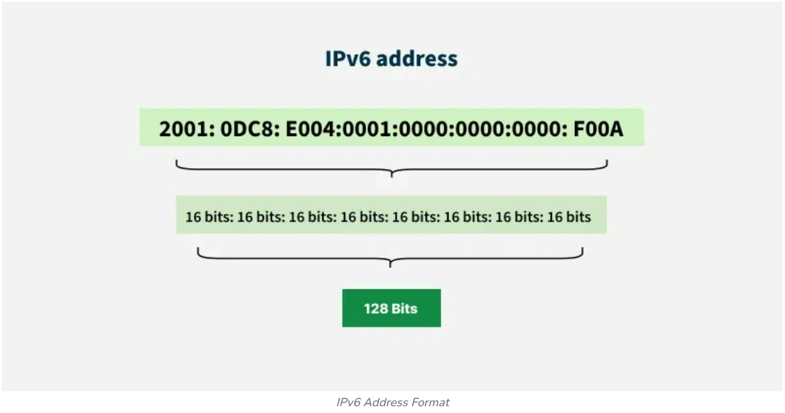
Example of IPv6 Address: 2001:0db8:85a3:0000:0000:8a2e:0370:73342001:0db8:85a3:0000:0000:8a2e:0370:7334 Each group (like 2001, 0db8, 85a3, etc.) represents a 16-bit block of the address.

Difference Between IPv4 and IPv6
The Internet Protocol (IP) assigns a unique address to each device, enabling communication over the internet.
- IPv4, the earlier version, uses 32-bit addresses, providing about 4.3 billion unique addresses, which are now nearly exhausted due to the rapid growth of the internet and IoT devices.
- IPv6, the newer version, uses 128-bit addresses, offering a vastly larger address space to overcome IPv4 exhaustion and support future internet expansion.
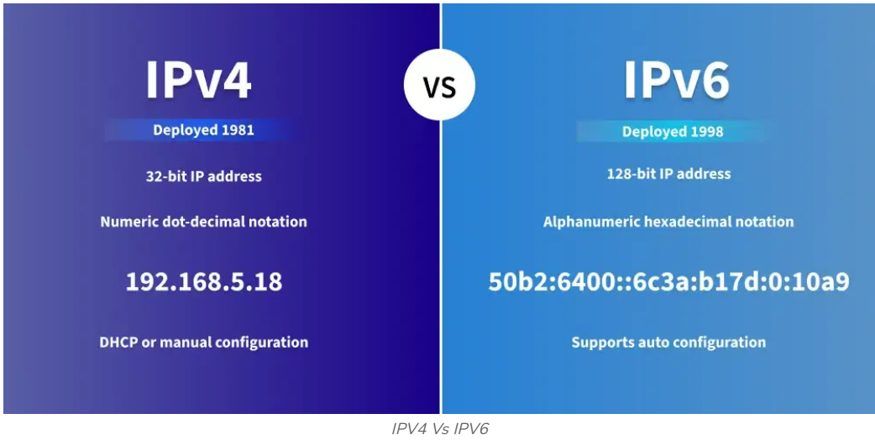

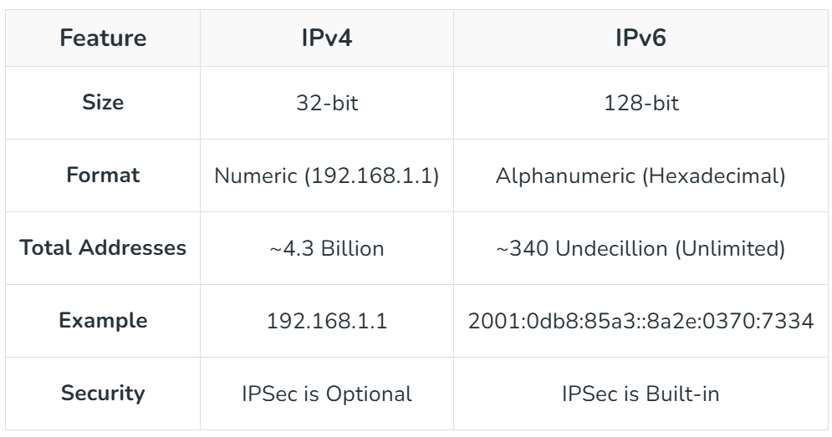
- Based on Assignment
Static IP Addresses
- Static IP Addresses are permanently assigned to a device, typically important for servers or devices that need a constant address.
- Reliable for network services that require regular access such as websites, remote management.
Dynamic (Ephemeral) IP Addresses:
- Temporarily assigned from a pool of available addresses by the Dynamic Host Configuration Protocol (DHCP).
- Cost-effective and efficient for providers, perfect for consumer devices that do not require permanent addresses.

- Based on Function
Unicast Address
In unicast, data is sent from one sender to one specific receiver identified by a unique IP address. It is the most common type of communication used in networks. Its Purpose is One-to-one communication.
- Example: Sending an email or loading a webpage - your computer directly communicates with a specific server.
- Use Case: Regular web browsing, file transfers (FTP), email (SMTP), etc.

Broadcast Address
In broadcast, a message is sent from one device to all devices in the same network segment. Every device in the network receives and processes the broadcast message. Its Purpose is One-to-all communication within a network.
- Example: An ARP (Address Resolution Protocol) request uses broadcasting to find a device’s MAC address on the local network.
- Use Case: Network discovery, DHCP requests, ARP queries
Note: Broadcast communication is supported in IPv4, but not in IPv6 (IPv6 replaces it with multicast).

Multicast Address
In multicast, data is sent from one source to multiple selected receivers that are part of a multicast group. Only devices that have joined the group will receive the data, making it more efficient than broadcasting. Its Purpose is One-to-many (selected group) communication.
- Example: Streaming live video or online conferencing to a group of users.
- Use Case: IPTV, video conferencing, live streaming
- IPv4 Range:224.0.0.0224.0.0.0 to 239.255.255.255239.255.255.255
- IPv6 Prefix:FF00::/8FF00::/8
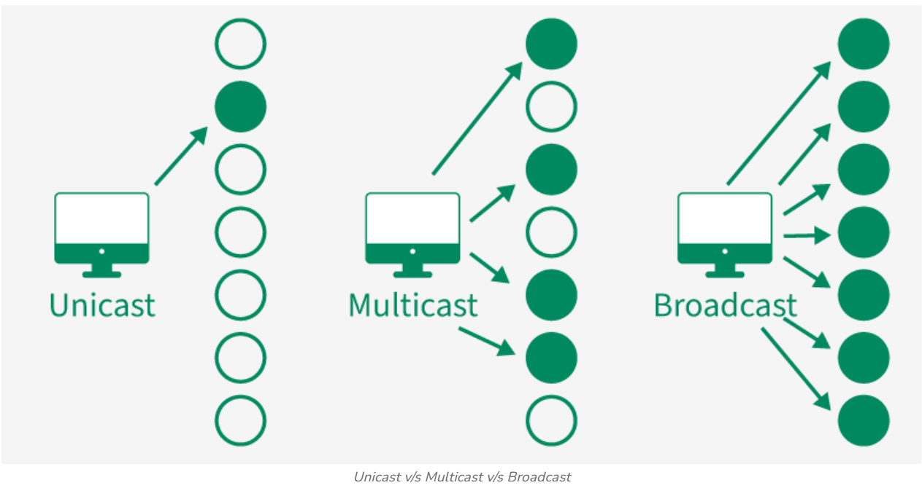

Anycast Address
In anycast, data is sent from one sender to the nearest receiver (in terms of network distance) among a group of devices sharing the same IP address. Routers determine the closest destination dynamically. Its Purpose is One-to-nearest communication (based on routing distance).
- Example: Content Delivery Networks (CDNs) use anycast to route user requests to the nearest data center.
- Use Case: DNS servers, CDN routing, load balancing
Note: Anycast is primarily used in IPv6, but it can also be implemented in IPv4.

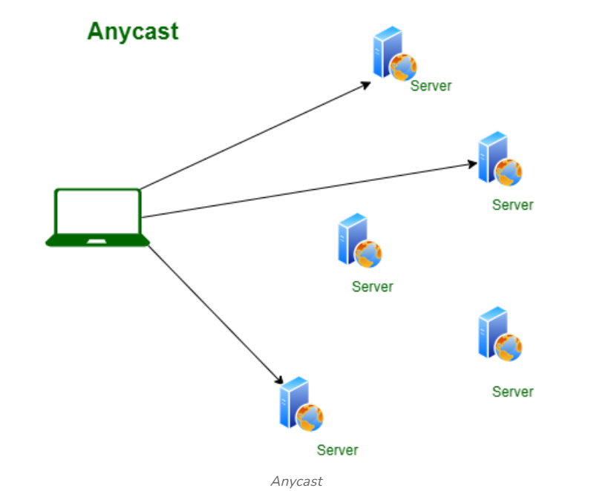

Broadcasting in Computer Network?
In computer network, there are various ways in which we can transmit data from one node to another node, one node to multiple node, and many node to many nodes. For each type of transmission, there's a term associated with it. Let's see their examples in brief :
- For node to node: 'Unicast' also known as POINT-TO-POINT communication. Example: cell phone conversation.
- When multiple POINT-TO-POINT communications are made its called - 'Multicast'. The message is received by only those hosts who choose to be a part of a multicast group. Example: Video conferencing, sending a message targeting number of people at at a time.
- One Node to ALL Nodes - Broadcasting. Today we'll discuss broadcasting in depth.

What is Broadcasting?
Broadcasting in computer networks is a type of communication mechanism that allows the message to be received by all the nodes of a network. The term broadcast in general refers to the transmission of signals from radio or televisions. Every broadcasted signal is stopped at layer-3 network layer of OSI or to be more practical - at the router.

Key Points on Broadcasting
- Data is sent to all the nodes/stations in the network domain.
- A special broadcast address exist for every network which is used to receive a broadcasted message.
- Not every device want to receive the broadcasted message.
- It generates the most network traffic because the broadcasted message is sent to every node in the network.
- It is less secure. A sensitive message shouldn't be sent to everyone and hence it should be kept in mind before broadcasting a message.
- Examples : Address Resolution Protocol (ARP) requests, Dynamic Host Configuration Protocol (DHCP) requests.
Advantages of Broadcasting
- Ease of communication: The main advantage of broadcasting is it allows the message to be delivered to every node in a network without establishing a POINT-TO-POINT communication channel which saves a lot of time & process overhead.
- Network Troubleshooting: One can easily identify the corrupt resource or potential security threats in a large network by sending a broadcast message.
- Reduced Network Traffic: Unlike unicast, which separately sends a message to each node in a network one by one resulting in high volume of traffic, and multicasting which also requires additional network infrastructure and can be complex to manage. But broadcasting doesn't require any additional network infrastructure and can simultaneously send data to all the nodes in a network without increasing traffic.
Disadvantages of Broadcasting
- Broadcast Storm: At any point of time if all of a sudden, a number of devices in a network choose to respond to a broadcasted message by sending another broadcast simultaneously then it would lead to higher network traffic and ultimately result in network failure.
- Limited Control & Security issue: When broadcasting a message, we have limited control i.e the data is sent to everyone. So any message before being broadcasted should be made sure that its intended user is everyone in the network.
- Broadcasting doesn't support large amount of devices, it also doesn't allow the message to be customized based on personal preferences.

Types of Broadcasting
There are 3 types of broadcasting mainly :
1. Limited Broadcast
It is a simplest broadcasting in which a message is transmitted to every node within a same network (the destination node exists within the same network), the scope of broadcast doesn't go beyond the local network. And an example IPv4 address would be - 255.255.255.255, and IPv6 : FF02::1
2. Directed Broadcast
In directed Broadcast, the message is sent to a specific group of hosts within a network that can be identified by their subnets. And the host bits of the destination IPv4 address are all set to 1. Example: 192.168.1.255
3. Subnet Broadcast
Subnetting refers to creating a smaller network within a larger network that shares a common network address. Whenever a message is to be broadcasted to a specific subnet within a larger network then its called subnet Broadcast. In this, the message is sent to the broadcast address of a specific subnet and the broadcast address of a subnet is the highest possible address. For example if the subnet address is : 192.168.1.0 & the subnet mask is 255.255.255.0 then the broadcast address would be 192.169.1.255.

How To Calculate Broadcast Address?
Case 1:
Consider an IP address of class A - 10.20.15.3 and the default subnet mask for class A is 255.0.0.0. In each octet, there are 8 bits. So now at bit-level we'll perform an OR operation on 'inverted' Subnet Mask. See the below diagram :
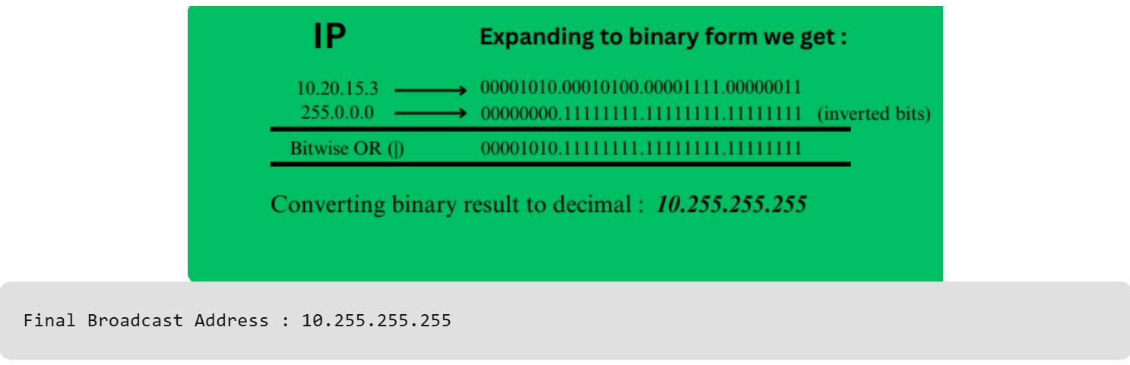

Case 2:
Consider an IP address of class C - 192.168.3.33 and the subnet mask given is: 255.255.255.248.
- IP Address = 192.168.3.33 = 11000000.10101000.00000011.00100001
- Subnet Mask = 255.255.255.248 = 11111111.11111111.11111111.11111000
👉 /29 (because 248 = 11111000 → 29 ones)
There is 29 network bits and Last 3 bits = host bits

Step 1: Find Network Address (AND)
Focus on last octet:
IP: 00100001
Mask: 11111000
-------------------------
Result: 00100000
👉 00100000 = 32
✔ Network Address = 192.168.3.32

Step 2: Find Broadcast Address
👉 Keep network bits same, make host bits = 1
Host bits = last 3 bits → 111
Network Address (last octet): 00100000
Broadcast: 00100111
👉 00100111 = 39
✔ Broadcast Address = 192.168.3.39
First usable = 192.168.3.33
Last usable = 192.168.3.38
Total hosts = 2³ − 2 = 6

💡 Key Insight
- /29 → 3 host bits
- Network → last 3 bits = 000
- Broadcast → last 3 bits = 111

Let’s find the Broadcast Address using Bitwise OR (|) method
IP Address: 192.168.3.33 = 11000000.10101000.00000011.00100001
Subnet mask: 255.255.255.248 = 11111111.11111111.11111111.11111000

Find Inverted Subnet Mask
👉 Invert all bits (0 ↔ 1)
11111111.11111111.11111111.11111000
00000000.00000000.00000000.00000111

Apply Bitwise OR (|)
Focus on last octet:
IP: 00100001 (33)
Inverted: 00000111 (7)
-------------------------------------------
Result: 00100111 (39)
Full result = 11000000.10101000.00000011.00100111

Convert to Decimal
👉 Broadcast Address = 192.168.3.39

🔹 Quick Mental Trick
Subnet mask = 255.255.255.248 = 11111111.11111111.11111111.11111000
CIDR = /29 → block size = 256 – 248 = 8
Blocks: 0-7, 8-15, 16-23, 24-31, 32-39, ……, …….
Last Octate of Given IP = 33 falls between range 32-39
👉 First IP = 32 = Network and Last IP = 39 = Broadcast
Network Address = 192.168.3.32 and Broadcast Address = 192.168.3.39

IP (IPv4) Address Classes
There are around 4.3 billion IPv4 addresses and managing all those addresses without any classification is next to impossible. For easier management and assignment IP addresses are organized in numeric order and divided into the following 5 classes:
Class A (1.0.0.0 to 127.255.255.255): Used for very large networks (like multinational companies). Supports up to 16 million hosts per network.
- Range: 1.0.0.0 – 126.255.255.255
- Network bits: 8
- Host bits: 24
- Default subnet mask: 255.0.0.0 (/8)
- Use: Large networks
- Example: Government organizations
- 127 is reserved for loopback

Class B (128.0.0.0 to 191.255.255.255): Used for medium-sized networks, such as large organizations. Supports up to 65,000 hosts per network.
- Range: 128.0.0.0 – 191.255.255.255
- Network bits: 16
- Host bits: 16
- Default subnet mask: 255.255.0.0 (/16)
- Use: Medium-sized networks
- Example: Universities

Class C (192.0.0.0 to 223.255.255.255): Used for smaller networks, like small businesses or home networks. Supports up to 254 hosts per network.
- Range: 192.0.0.0 – 223.255.255.255
- Network bits: 24
- Host bits: 8
- Default subnet mask: 255.255.255.0 (/24)
- Use: Small networks
- Example: Home and small businesses

Class D (224.0.0.0 to 239.255.255.255): Reserved for multicast groups (used to send data to multiple devices at once). Not used for traditional devices or networks.
- Range: 224.0.0.0 – 239.255.255.255
- Use: Multicast communication
- Example: Video streaming

Class E (240.0.0.0 to 255.255.255.255): Reserved for experimental purposes and future use.
- Range: 240.0.0.0 – 255.255.255.255
- Use: Experimental and research
- Not used for public networking

Special IP Addresses
There are also some special-purpose IP addresses that don't follow the usual structure:
- Loopback Address: The loopback address 127.0.0.1127.0.0.1 is used to test network connectivity within the same device (i.e., sending data to yourself). Often called "localhost."
- Broadcast Address: The broadcast address allows data to be sent to all devices in a network. For a typical network with the IP range 192.168.1.0/24192.168.1.0/24, the broadcast address would be 192.168.1.255192.168.1.255.
- Multicast Address: Used to send data to a group of devices (multicast). For example, 233.0.0.1233.0.0.1 is a multicast address.

What is "Network ID" and "Host ID" in IP Addresses?
Network ID → Identifies the specific network to which a device belongs. All devices on the same physical network share the same network ID.
Host ID → Uniquely identifies a specific device (computer, server, printer) within that network.
Subnet Mask → Used to distinguish which part of the IP address is the Network ID and which is the Host ID.

IP address is divided into two parts that is Network ID and Host ID. Network ID indicates the specific network to which the address belongs. Host ID Identifies the specific device within that network. Together, these components enable efficient routing of data packets across the networks, ensuring proper delivery to the correct device.
Initially in 1980 IP address was divided into two fixed parts NID=8 bit and HID=24 bit. NID (Network ID) represents the entire network for a specified host. HID (Host ID) represents a specified user IP address within the network. So there are only 2⁸ i.e., 256 networks are available and there are 2²⁴ i.e., 16M hosts per network. If even a small organization wants to purchase a network then it should buy one network in which there are 16M hosts that can be connected this is the drawback of this fixed representation of IP address.
IP addresses are divided into 5 classes:
- Class A is used for big networks such as ISP networks.
- Class B is used by big organizations.
- Class C is used by small organizations.
- Class D no NID and HID all 28 bits are used to define the multicast address.
- Class E is reserved for research and future purchases.
Range of All Classes
Class A: 1.0.0.0 to 127.255.255.255
Class B: 128.0.0.0 to 191.255.255.255
Class C: 192.0.0.0 to 223.255.255.255
Class D: 224.0.0.0 to 239.255.255.255
Class E: 240.0.0.0 to 255.255.255.255

What is Network ID?
A network ID also known as NetID is a fixed bit in the IP address that represents the entire network of any host It is connected to the network. i.e., it tells the network of the host by which the host is connected.
The total size of the IP address is 32 bits and the IP address is divided into four octets each of size is 8 bits. And further, divide into NID and HID. Let's discuss each class in detail.
Class A: The first octet represents NID so there are 8 bits for NID and 24 bits for HID. And the first bit of the first octet is always 0.
Class B: The first two octets represent NID so there are 16 bits for NID and 16 bits for HID. And the first two bits of the first octet are fixed i.e., 10.
Class C: The first three octets represent NID so there are 24 bits for NID and 8 bits for HID. The first three bits of the first octet are fixed i.e., 110.
Class D: All bits are fixed for NID.
Class E: All bits are fixed for NID.
The network ID uses a prefix based on its class. Classes A, B, C, D, and E use prefixes '0', '10', '110', '1110', and '1111 0', respectively. These prefixes are binary patterns, not decimal. A prefix = first few bits of the IP address (in binary). These bits tell us which class the IP belongs to.
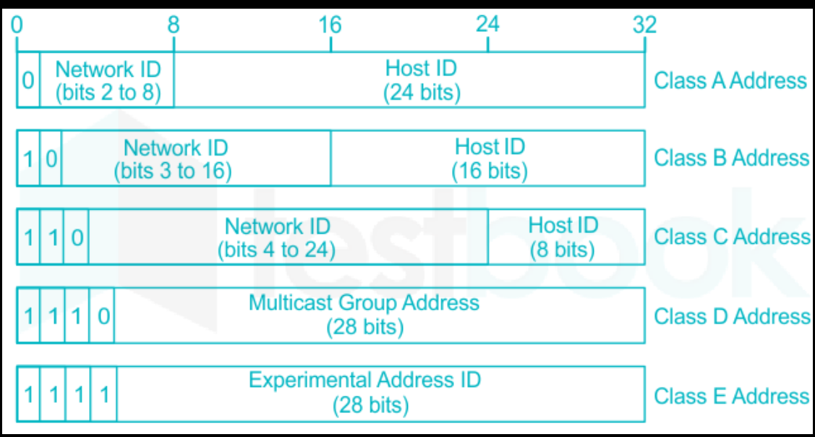

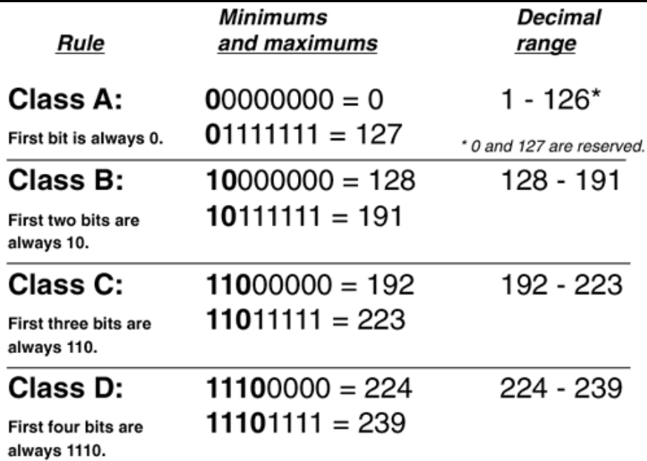
Additionally, as seen in the graphic below, each class has a different number of octets reserved for the host ID. Class A reserves 3 octets, class B reserves 2, class C reserves 1, and class D/E have no reserved octets for the host ID.
Combining these two facts, we see that Classes A, B, C, D, and E use 7, 14, 21, 28, and 27 bits, respectively, for the actual network ID.
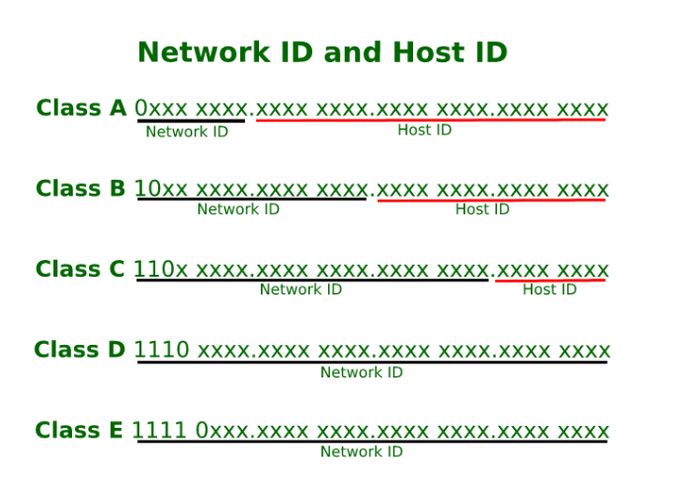
What is Host ID?
It is the fragment of an IP address that uniquely identifies a host within a network. The network ID can be found by ANDing the IP (in binary) and subnet mask (in binary). The host ID is found in the same way, except one must first invert the subnet mask (not an official term, but could that binary value the 'host mask').
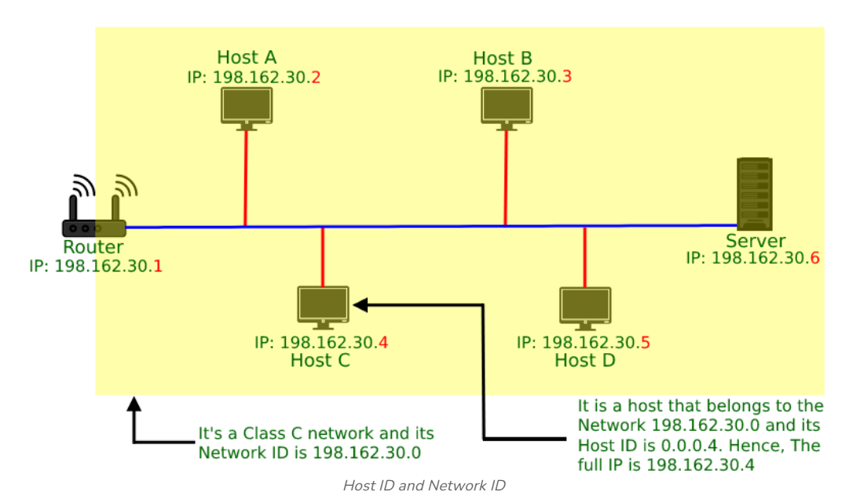
For Example, In the above Image, the IP address of host C is 198.162.30.4 which means it belongs to class C, so its default subnet mask will be 255.255.255.0; Now applying AND on both, it will give the host ID 0.0.0.4 and network ID 198.162.30.0.
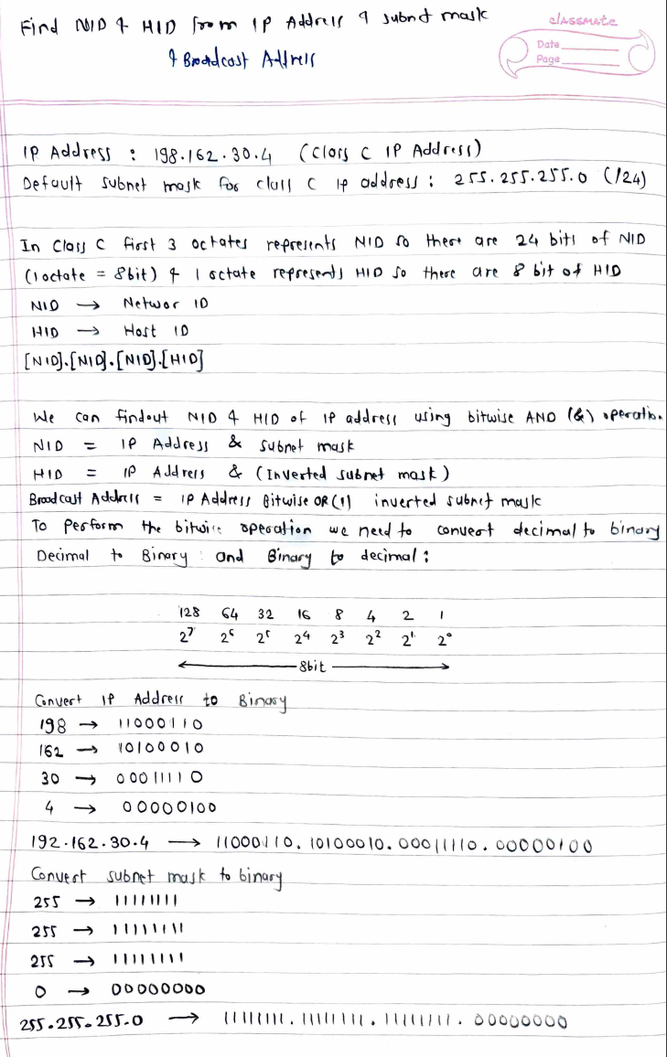
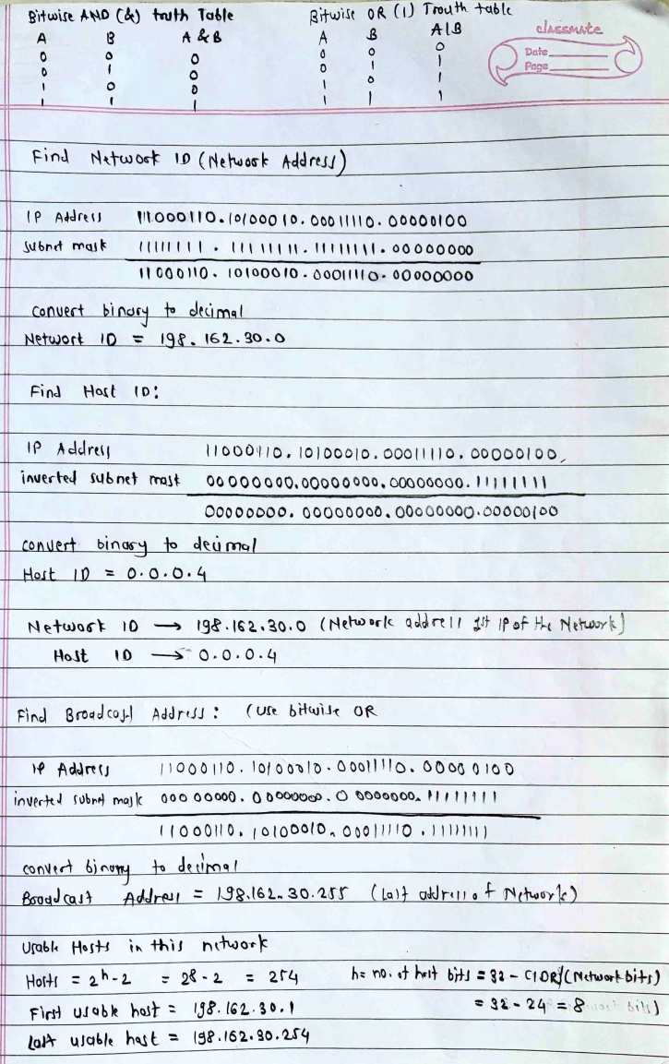
Question 1: What is the network address and broadcast address if the destination address is 200.45.34.56 and the subnet mask is 255.255.255.240?
Method 1:
IP Address = 200.45.34.56
Subnet Mask = 255.255.255.240
Step 1: Find Subnet / CIDR
Mask: 255.255.255.240 👉 (11111111.11111111.11111111.11110000) binary
👉 Last octet = 240 → binary: 11110000
👉 So, /28 (because 28 bits are 1)

Step 2: Find Block Size
Block size = 256 − subnet value
256 − 240 = 16
👉 So subnet ranges increase by 16

Step 3: Identify the Range
Subnets in last octet:
- 0 – 15
- 16 – 31
- 32 – 47
- 48 – 63
- ...
👉 Given IP = 56
✔ Falls in range: 48 – 63

Step 4: Find Network Address
👉 First IP of range = Network Address
✔ Network Address = 200.45.34.48
Step 5: Find Broadcast Address
👉 Last IP of range = Broadcast Address
✔ Broadcast Address = 200.45.34.63

Bonus (Usable Hosts)
First usable = 200.45.34.49
Last usable = 200.45.34.62
Total hosts = 16 − 2 = 14

💡 Quick Trick to Remember
Block size = 16
Find nearest multiple of 16 ≤ IP (56) → 48
Network = 48
Broadcast = 48 + 15 = 63

Method 2: Using binary method
IP Address = 200.45.34.56
IP Address in binary = 11001000.00101101.00100010.00111000
Subnet Mask = 255.255.255.240 (/28)
Subnet mask in binary = 11111111.11111111.11111111.11110000
First 28 bits = network, last 4 bits = host

Find Network Address (AND operation)
IP: 11001000.00101101.00100010.00111000
Mask: 11111111.11111111.11111111.11110000
----------------------------------------------------------------------
Result: 11001000.00101101.00100010.00110000

Covert binary to decimal
✔ Network Address = 200.45.34.48

Find Broadcast Address

👉 Keep network bits same, make all host bits = 1
Host bits = last 4 bits → 1111

Network (last octet): 00110000
Make host bits 1 (last 4 bit): 00111111

Covert binary to decimal
00111111 = 63

✔ Broadcast Address = 200.45.34.63

💡 Key Understanding
- Mask /28 → last 4 bits = host
- Network → host bits = 0000
- Broadcast → host bits = 1111

Formula to Calculate Hosts per Network
The number of usable hosts in a subnet is:
Hosts=2^{h} - 2
Where:
- h = number of host bits (bits available for hosts)
- −2 is because:
  - 1 address = Network address → identifies the subnet (not usable)
  - 1 address = Broadcast address → used to send to all hosts (not usable)
How to Find Host Bits?
H = 32 − Subnet mask (CIDR)

🔹 Important Distinction
Term | Formula | Meaning
Total IPs | 2^{h} | Includes network + broadcast
Usable Hosts | 2^{h} - 2 | Devices you can assign IPs to

🔹 Example 1
- Subnet: /24
- Host bits: 32−24=8
- Hosts: 2⁸ - 2 = 256 - 2 = 254
👉 Usable hosts = 254

🔹 Example 2
- Subnet: /26
- Host bits: 32−26=6
- Hosts: 2⁶ - 2 = 64 - 2 = 62
👉 Usable hosts = 62

🧠 Quick Reference Table
CIDR | Host Bits | Usable Hosts
/24 | 8 | 254
/25 | 7 | 126
/26 | 6 | 62
/27 | 5 | 30
/28 | 4 | 14

An IPv4 address is a unique address assigned to each device (host or router) on the Internet.
- It is made up of 32 bits, divided into four octets (x.y.z.t).
- Each IP has two parts:
1. Network ID Identifies the network
2. Host ID Identifies the device (host) inside that network
An IP actually refers to a network interface, not just a host. If a host is on two networks, it needs two IP addresses.
Default Mask
A mask helps separate the network part and the host part of an IP address.
- If a mask bit is 1 ,It belongs to the network.
- If a mask bit is 0 ,It belongs to the host.
Example:
- IP: 192.168.1.1
- Mask: 255.255.255.0
First 24 bits (1’s) i.e Network
Last 8 bits (0’s) i.e Host

The network address identifies a specific subnet (first address, host bits = 0) and cannot be assigned to hosts. The broadcast address (last address, host bits = 1) communicates with all devices in that subnet. Both are reserved and cannot be assigned to individual devices.
Network Address
- Definition: The first address in a subnet, used to identify the network (not assignable to hosts).
- How to find:
Set all host bits to 0, or
IP AND Subnet Mask
Example: IP:- 192.168.1.100/24 i.e Network = 192.168.1.0

Broadcast Address
- Definition: The last address in a subnet, used to reach all hosts in that network (not assignable to hosts).
- How to find:
Set all host bits to 1, or
IP OR (NOT Subnet Mask)
Example: IP:- 192.168.1.100/24 i.e Broadcast = 192.168.1.255

CIDR (Classless Inter-Domain Routing)
CIDR uses the format x.y.z.t/n, where:
- x.y.z.t = IP Address
- n = Number of bits for the network part (1’s in mask)
Example: 192.168.32.1/24
- Means first 24 bits are for network, last 8 bits are for host.

Example 1:
CIDR: 192.168.32.1/24
- IP (Binary): 11000000 10101000 00100000 00000001
- Mask: /24 → 255.255.255.0 (24 bits network, 8 bits host)
Steps:
- Network Address: set last 8 bits to 0 i.e 192.168.32.0
- Broadcast Address: set last 8 bits to 1 i.e 192.168.32.255
Class: C

Example 2:
CIDR: 205.15.37.39/28
- IP (Binary): 11001101 00001111 00100101 00100111
- Mask: /28 → 255.255.255.240 (28 bits network, 4 bits host)
Steps:
- Network Address: last 4 bits = 0 i.e 205.15.37.32
- Broadcast Address: last 4 bits = 1 i.e 205.15.37.47
Class: C

Introduction to Subnetting
Subnetting is the process of dividing a large IP network into smaller, manageable, and logical sub-networks (subnets) to enhance network performance, security, and IP address efficiency. It involves borrowing host bits from an IP address to create additional network bits, allowing for localized traffic control and reduced broadcast traffic.
A subnet, or subnetwork, is a network inside a network. Subnets make networks more efficient. Through subnetting, network traffic can travel a shorter distance without passing through unnecessary routers to reach its destination.
Subnetting is the process of dividing a large IP network into smaller logical networks called subnets. Each subnet allows devices to communicate efficiently, improving network performance, security, and manageability.
- Each department is assigned a separate subnet
- Devices within a department communicate using their own subnet
- Inter-department traffic is routed through a router
- Broadcast traffic is limited to each subnet
- Network performance, security, and management are improved
This approach keeps departmental traffic separate, organized, and efficient, which is exactly what subnetting is designed to achieve.

Need of Subnetting
Subnetting enables a single IP network to be divided into smaller, logical networks, allowing for efficient IP address usage, improved performance, and enhanced security control.
Let's consider a company that follows classful addressing. It has a Class C network (192.168.1.0/24) with 256 IP addresses. It has three departments:
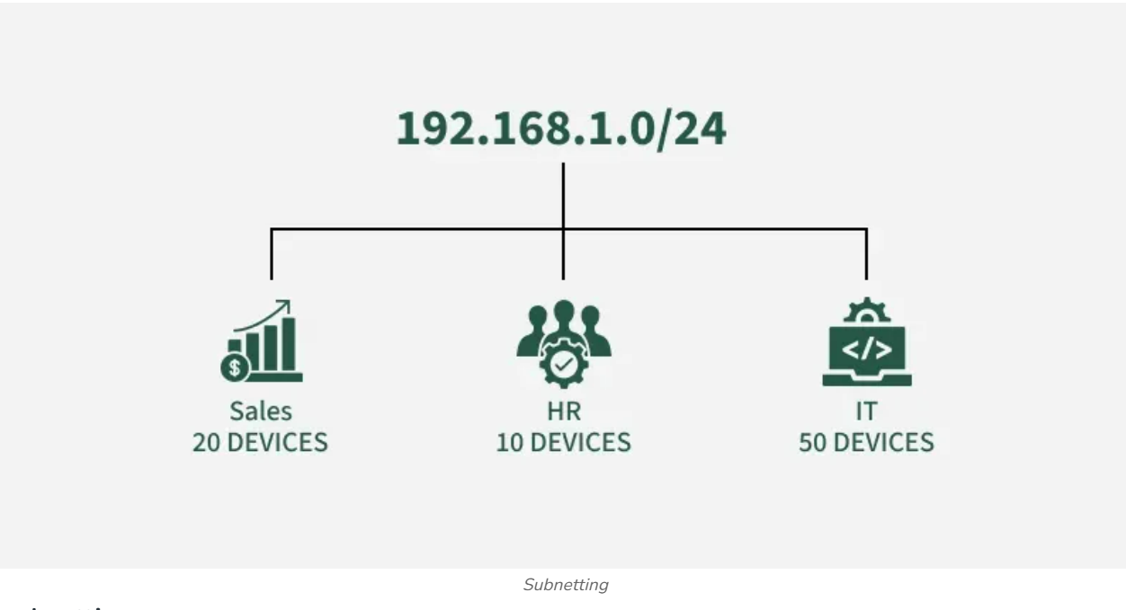
Without subnetting:
- All departments share the same network
- Only 80 IP addresses are used, leaving 176 unused
- Broadcast traffic floods the entire network
- Devices from different departments can access each other freely
With subnetting:
- The network is divided into three smaller subnets
- Each department receives only the IPs it needs
- Traffic remains within each subnet, improving performance
- Departments are logically isolated, improving security
- IP addresses are used efficiently, with room for future growth
Department | Devices | IPs Allocated (after subnetting)
Sales | 20 | 32 (192.168.1.0/27)
HR | 10 | 16 (192.168.1.32/28)
IT | 50 | 64 (192.168.1.48/26)

By subnetting, we:
- Use IP addresses efficiently, allocating only what each department requires
- Improve network performance by containing traffic within each subnet
- Enhance security by isolating departments from one another

Key Concepts in Subnetting
IP Addressing: An IP address uniquely identifies a device on a network and is divided into logical parts to support routing and communication. An IPv4 address is a 32-bit value written as four octets separated by dots (for example, 192.168.1.1).
- Network portion: Identifies the network to which the device belongs
- Host portion: Identifies the specific device within that network
In classful IPv4 addressing, IP addresses are divided into classes based on how many bits are used for the network ID and host ID.
- Class A: 8-bit network ID, 24-bit host ID
- Class B: 16-bit network ID, 16-bit host ID
- Class C: 24-bit network ID, 8-bit host ID
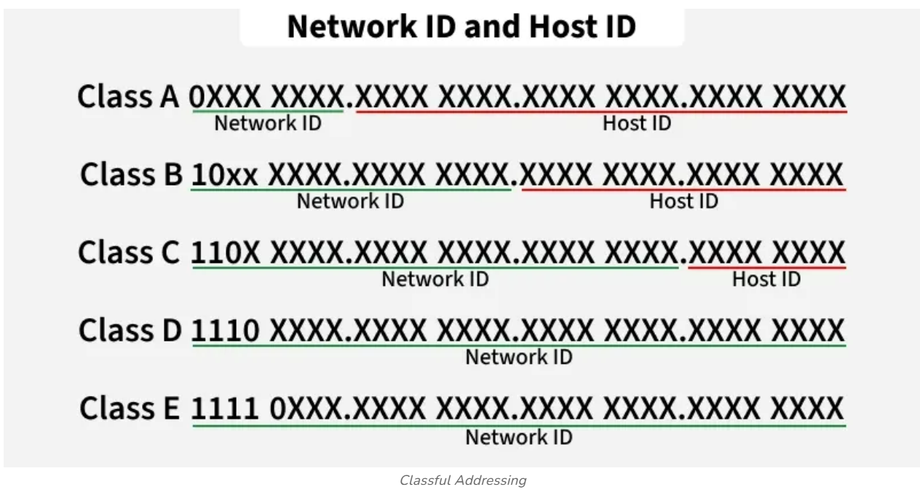
Subnet Mask
A subnet mask is a 32-bit number used in IP addressing to separate the network portion of an IP address from the host portion. It helps computers and devices determine which part of an IP address refers to the network they are present, and which part refers to their specific location or address within that network.
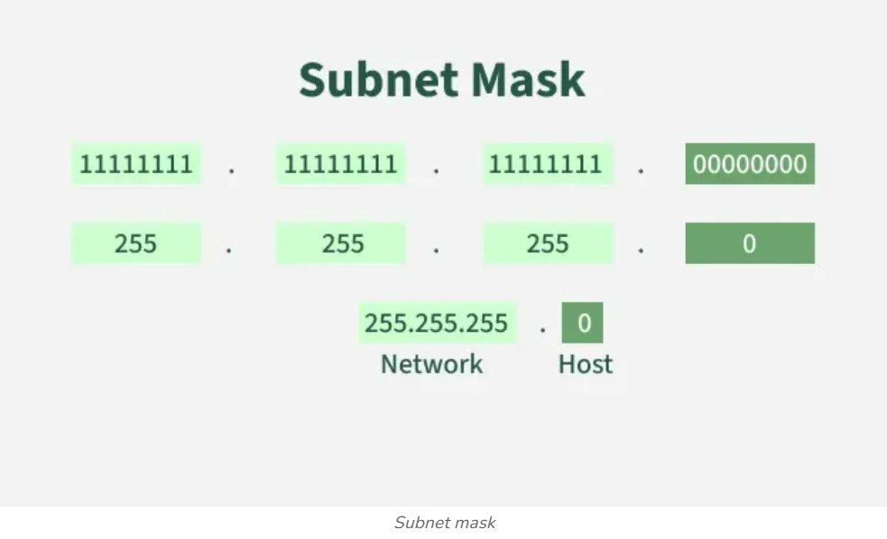
A subnet mask is a 32-bit number that divides an IPv4 address into network and host components, allowing devices to identify if a destination is local or on another network. Typically written in dotted-decimal (e.g., 255.255.255.0) or CIDR notation (e.g., /24), it masks the network portion to optimize routing and enhance traffic management.
Common Subnet Masks:
- 255.255.255.0 (/24): Allows for 254 usable host IP addresses.
- 255.255.0.0 (/16): Allows for 65,534 usable host IP addresses.
- 255.0.0.0 (/8): Allows for 16,777,214 usable host IP addresses.
The smaller the subnet mask number, the larger the network range.

Role of Subnet Mask
A subnet mask is a 32-bit number used with an IP address to divide it into two parts:
- the network ID, and
- the host ID.
In a subnet mask:
- Binary 1s represent the network portion of the IP address.
- Binary 0s represent the host portion.
The subnet mask helps a device determine whether another device is on the same local network or on a different network, which in turn decides whether communication is direct or must go through a router.
For example:
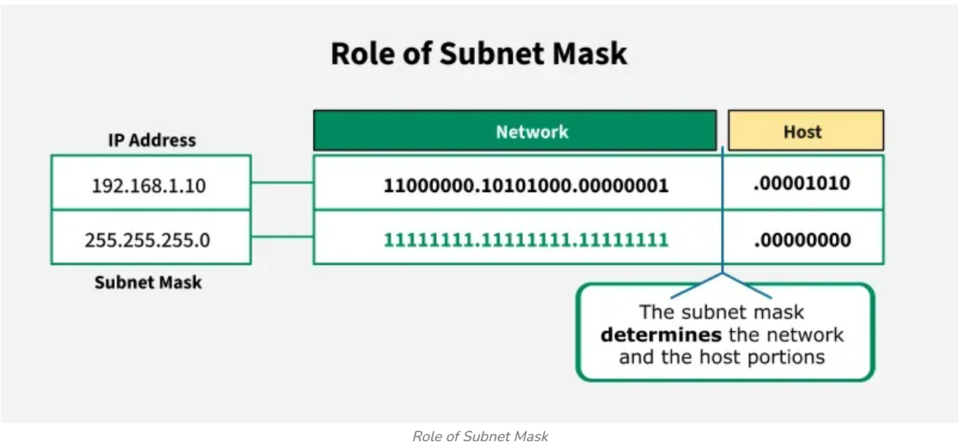
Subnet masks help divide a large network into smaller logical networks called subnets, which improves network efficiency, security, and performance by reducing broadcast traffic and enabling better network management.
Function of Subnet Mask
- Separates an IP address into network ID and host ID.
- Divides a large network into smaller subnets for better organization.
- Improves network efficiency, security, and manageability by reducing unnecessary traffic.
- Helps routers determine whether a packet should be forwarded locally or to another network.
Why Use a Subnet Mask?
Consider a Class A network, which can support approximately 16 million hosts. Managing such a large network as a single unit is impractical and introduces several challenges:
- Maintenance becomes difficult due to the large number of connected devices.
- Security risks increase, as all devices share the same network.
For example, in an organization with multiple departments, allowing every department access to the entire network is neither efficient nor secure.
Solution: Subnetting
Subnetting addresses these issues by dividing a large network into smaller, manageable sub-networks called subnets using a subnet mask. Each department can be assigned its own subnet, which:
- Improves security by isolating departments
- Enhances network efficiency by reducing unnecessary traffic
- Simplifies network management
In a network without subnetting, identifying a device involves three steps:
- Identification of the network
- Identification of the host
- Identification of the process
When subnetting is applied, address identification becomes more structured and involves four steps:
- Identification of the network
- Identification of the subnet
- Identification of the host
- Identification of the process
Suppose we have a Class C network and we want to divide it into 4 subnets. To divide we need to choose 2 bits from the host part.
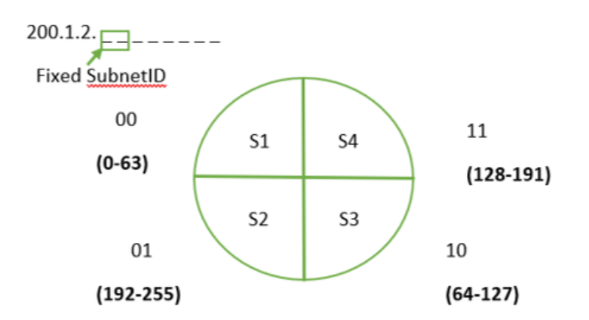
As the first and last IP addresses are reserved for network ID and directed broadcast address in every subnet, we have to reserve 8 IP addresses in this case.
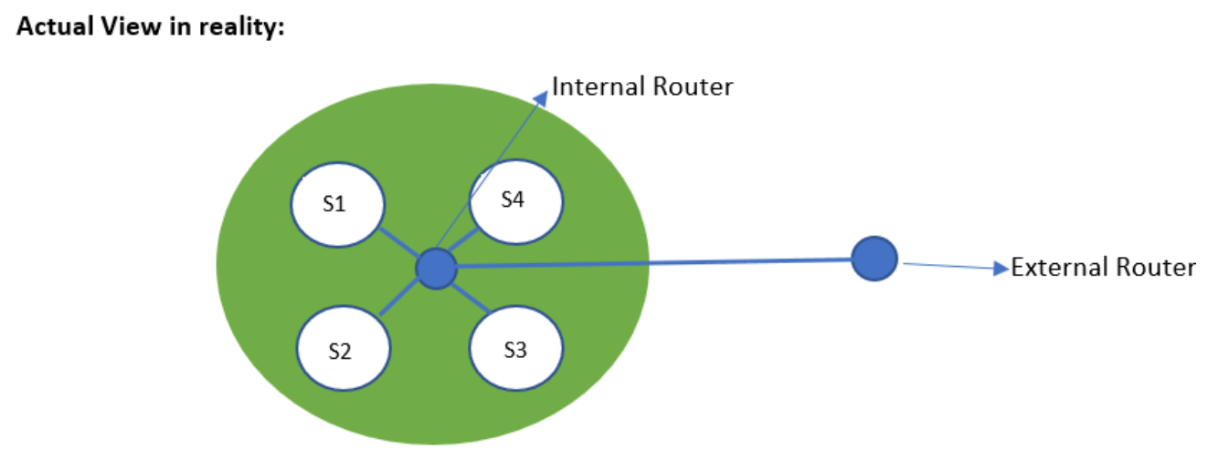
Representation of Subnet Masks
Class C Network: 200.1.2.0/24 i.e. divided into 4 subnets.
- Borrow 2 bits from the host part.
- Subnet mask: 255.255.255.192
- Binary: 11111111.11111111.11111111.11000000
Subnet Matching (Bitwise AND):
IP Address: 200.1.2.20 → 11001000.00000001.00000010.00010100
Subnet Mask: 255.255.255.192 → 11111111.11111111.11111111.11000000
Result: 200.1.2.0 → 11001000.00000001.00000010.00000000
So, IP 200.1.2.20 belongs to subnet 200.1.2.0/26.
Routing Table and Subnet Matching
If the network id doesn’t matches with any of the subnet mask then the packet will be sent to default entry.
Default entry has network id as 0.0.0.0.
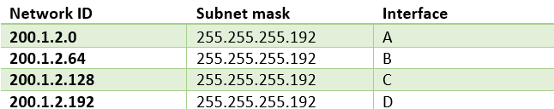
In some cases the network id may match with two entries in the routing table, so here the interface having the longest subnet mask (more 1’s) is selected.
Network Classes
The Internet Assigned Numbers Authority (IANA), through InterNIC, manages the allocation of IP addresses.
To simplify addressing, IP addresses are divided into five classes (A–E):
- Class A, B, C: Commonly used by end users.
- Class D: Reserved for multicast.
- Class E: Reserved for experimental purposes.
Each class has a default subnet mask, and the first octet (first 8 bits) determines the class.
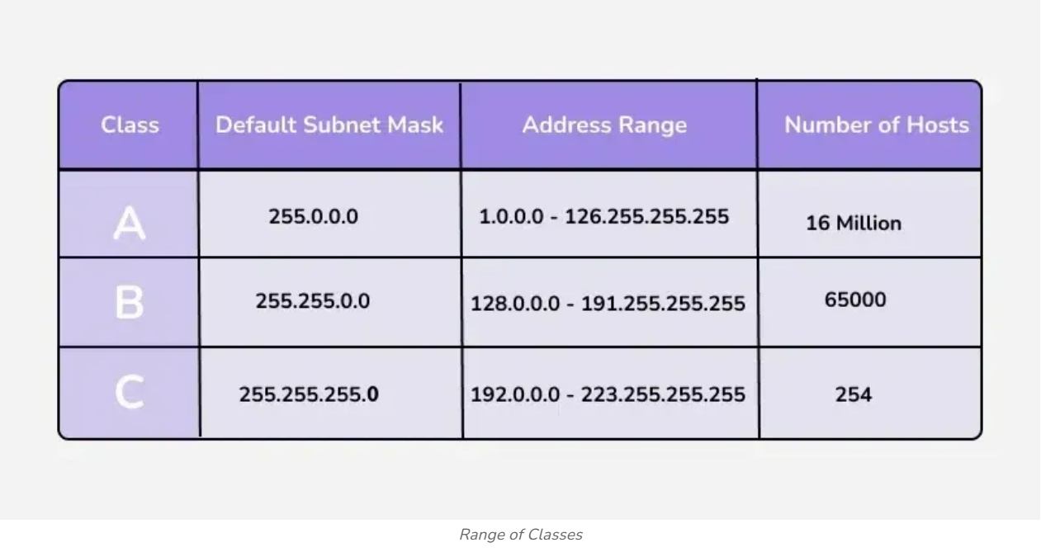
Advantages of Subnetting
- Reduces Congestion: Limits broadcast traffic, improving network performance.
- Efficient IP Usage: Allocates IPs based on need, avoiding wastage.
- Enhanced Security: Isolates sensitive data within specific subnets.
- Departmental Segmentation: Prioritizes traffic for specific teams or services.
- Scalable & Organized: Makes network expansion easier and manageable.
Disadvantages of Subnetting
- Fewer Usable Addresses: Network and broadcast IDs reduce host capacity.
- Higher Hardware Costs: Routers or Layer-3 devices are often required.
- Complex Setup: Needs careful planning and technical expertise.
- Compatibility Issues: Legacy devices may not support modern subnets.

Classless Inter Domain Routing (CIDR)
CIDR(Classless Inter Domain Routing) is a method of IP address allocation and routing that allows more efficient use of IP addresses. Unlike traditional class-based addressing, CIDR allocates IP addresses based on a network prefix rather than a fixed class (A, B, or C).
Classless Inter-Domain Routing (CIDR) is an IP address allocation method that improves data routing efficiency on the internet. Every machine, server, and end-user device that connects to the internet has a unique number, called an IP address, associated with it. Devices find and communicate with one another by using these IP addresses. Organizations use CIDR to allocate IP addresses flexibly and efficiently in their networks.
CIDR Notation: a.b.c.d/n
- n = number of bits in the network prefix.
- Example: 192.168.1.0/24 first 24 bits are the network, and the remaining 8 bits are the host ID.

Why CIDR?
Classful addressing wastes IP addresses:
Class | IPs Available | Hosts | Example Wastage
A | 2²⁴ | 2²⁴ - 2 | Too large for small orgs
B | 2¹⁶ | 2¹⁶ - 2 | Wastes 49,150 hosts for 214 needed
C | 2⁸ | 2⁸ - 2 | Small networks only

Problem: Organizations often need a number of hosts that do not match class sizes, leading to wastage.
Solution: CIDR allows flexible block allocation matching exact requirements.

Rules for Forming CIDR Blocks
- All IPs must be contiguous.
- Block size must be a power of 2 (2ⁿ) simplifies network division.
- First IP of block divisible by block size least significant bits of host ID should be 0.
Example: If the Block size is 2⁵ then, Host Id will contain 5 bits and Network will contain 32 - 5 = 27 bits.
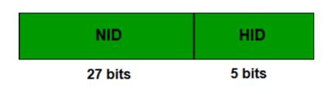
First IP address of the Block must be evenly divisible by the size of the block. in simple words, the least significant part should always start with zeroes in Host Id. Since all the least significant bits of Host Id is zero, then we can use it as Block Id part.
Example: Check whether 100.1.2.32 to 100.1.2.47 is a valid IP address block or not?
- All the IP addresses are contiguous.
- Total number of IP addresses in the Block = 16 = 2⁴.
- 1st IP address: 100.1.2.00100000 Since, Host Id will contains last 4 bits and all the least significant 4 bits are zero. Hence, first IP address is evenly divisible by the size of the block.
All three rules are followed by this Block. Hence, it is a valid IP address block.

Advantages of CIDR
- Efficient IP usage: Minimizes IPv4 address wastage.
- Flexible allocation: Supports networks of any size.
- Improved routing: Aggregates addresses for faster, simpler routing.
- Lower administrative overhead: Easier IP and network management.
Disadvantages of CIDR
- Complexity: CIDR is more complex to implement and manage compared to traditional class-based addressing.
- Compatibility Issues: Some older network devices may not support CIDR.
- Security Concerns: Implementing security measures like firewall rules and access control lists can be more difficult.

Classful vs Classless Addressing
Classful and Classless addressing are methods used in networking to manage IP addresses. Classful addressing divides IP addresses into fixed classes (A, B, C, D, E), each with predefined ranges. In contrast, classless addressing, also known as CIDR (Classless Inter-Domain Routing), offers more flexibility by allowing addresses to be subdivided into smaller blocks called subnets. This flexibility helps optimize address allocation and supports the growth of the internet by efficiently managing IP address resources.
Classful Addressing
Classful addressing was introduced in 1981, with classful routing, IPv4 addresses were divided into 5 classes(A to E), each with a predetermined range. The class of an IP address determines the network portion and the host portion based on its class-specific subnet mask. Classful addressing was inflexible and led to inefficiencies in address allocation, which prompted the development of classless addressing (CIDR) for more efficient use of IP address space.
- Classes A-C: unicast addresses
- Class D: multicast addresses
- Class E: reserved for future use
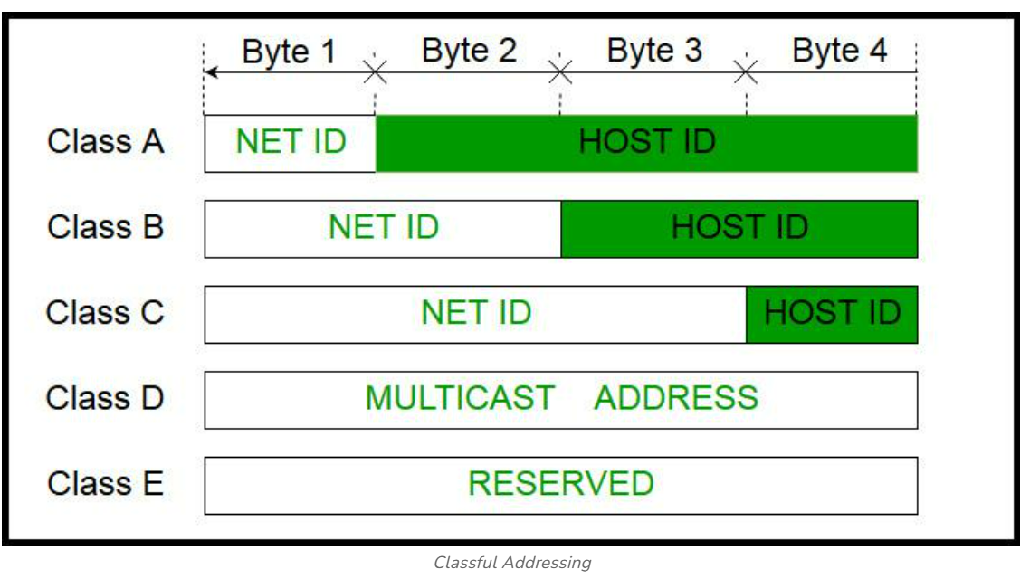
Class A
In a class A address, the first bit of the first octet is always '0'. Thus, class A addresses range from 0.0.0.0 to 127.255.255.255(as 01111111 in binary converts to 127 in decimal). The first 8 bits or the first octet denote the network portion and the rest 24 bits or the 3 octets belong to the host portion. Its Subnet mask is 255.0.0.0.
Example: 10.1.1.1
Exception -
- 127.X.X.X is reserved for loopback
- 0.X.X.X is reserved for default network
Therefore, the actual range of class A addresses is: 1.0.0.0 to 126.255.255.255
Class B
In a class B address, the first octet would always start with '10'. Thus, class B addresses range from 128.0.0.0 to 191.255.255.255. The first 16 bits or the first two octets denote the network portion and the remaining 16 bits or two octets belong to the host portion. Its Subnet mask is 255.255.0.0.
Example: 172.16.1.1
Class C
In a class C address, the first octet would always start with '110'. Thus, class C addresses range from 192.0.0.0 to 223.255.255.255. The first 24 bits or the first three octets denote the network portion and the rest 8 bits or the remaining one octet belong to the host portion. Its Subnet mask is 255.255.255.0.
Example: 192.168.1.1
Class D
Class D is used for multicast addressing and in a class D address the first octet would always start with '1110'. Thus, class D addresses range from 224.0.0.0 to 239.255.255.255. Its Subnet mask is not defined.
Example: 239.2.2.2
Class D addresses are used by routing protocols like OSPF, RIP, etc.
Class E
Class E addresses are reserved for research purposes and future use. The first octet in a class E address starts with '1111'. Thus, class E addresses range from 240.0.0.0 to 255.255.255.255. Its Subnet mask is not defined.
- Class A with a mask of 255.0.0.0 can support 128 Network, 16,777,216 addresses per network and a total of 2,147,483,648 addresses.
- Class B with a mask of 255.255.0.0 can support 16,384 Network, 65,536 addresses per network and a total of 1,073,741,824 addresses.
- Class C with a mask of 255.255.255.0 can support 2,097,152 Network, 256 addresses per network and a total of 536,870,912 addresses.
But what if someone requires 2000 addresses ?
One way to address this situation would be to provide the person with class B network. But that would result in a waste of so many addresses. Another possible way is to provide multiple class C networks, but that too can cause a problem as there would be too many networks to handle.
Problems With Classful Addressing
Classful addressing resulted in inefficient IP address utilization due to fixed address classes.
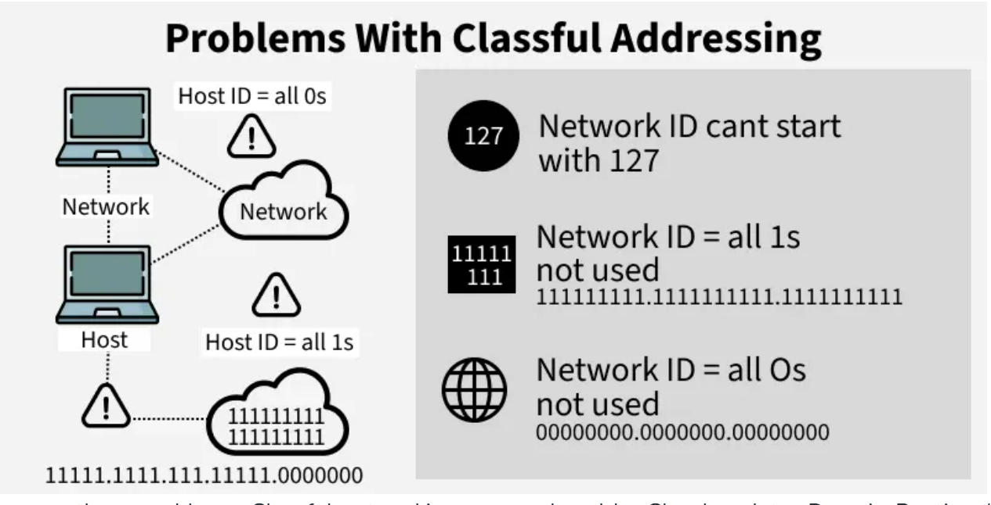
Since there are these problems, Classful networking was replaced by Classless Inter-Domain Routing (CIDR) in 1993. We will be discussing Classless addressing in the next post.
- The network ID is 24 bits long, and the host ID is 8 bits long.
- Total network addresses = 221=2,097,1522^{21} = 2,097,152221=2,097,152.
- Total host addresses per network = 28−2=2542^8 - 2 = 25428−2=254.
- The host ID must be unique within a network.
- Host ID with all 0s reserved for network ID.
- Host ID with all 1s reserved for broadcast address.
- Network IDs starting with 127 are reserved for loopback testing.
To resolve problems like the one mentioned above CIDR was introduced.

Classless Addressing
Classless Addressing or Classless Inter-Domain Routing was introduced in 1993 to replace classful addressing. Classless Inter-Domain Routing (CIDR) is a method for efficiently allocating IP addresses and routing Internet Protocol (IP) packets. Unlike classful addressing, which divides IP addresses into fixed classes (A, B, C, etc.), CIDR allows for variable-length subnet masks (VLSM). This means that networks can be divided into smaller, more flexible subnets according to their specific needs, rather than being constrained by predefined class boundaries.
Classless or Classless Inter-Domain Routing (CIDR) addresses use variable length subnet masking (VLSM) to alter the ratio between the network and host address bits in an IP address. A subnet mask is a set of identifiers that returns the network address’s value from the IP address by turning the host address into zeroes.
A VLSM sequence allows network administrators to break down an IP address space into subnets of various sizes. Each subnet can have a flexible host count and a limited number of IP addresses. A CIDR IP address appends a suffix value stating the number of network address prefix bits to a normal IP address.
For example, 192.0.2.0/24 is an IPv4 CIDR address where the first 24 bits, or 192.0.2, is the network address.

CIDR Notation
In CIDR subnet masks are denoted by /X. For example a subnet of 255.255.255.0 would be denoted by /24. To work a subnet mask in CIDR, we have to first convert each octet into its respective binary value. For example, if the subnet is of 255.255.255.0. then :
First Octet
255 has 8 binary 1's when converted to binary
Second Octet
255 has 8 binary 1's when converted to binary
Third Octet
255 has 8 binary 1's when converted to binary
Fourth Octet
0 has 0 binary 1's when converted to binary
Therefore, in total there are 24 binary 1's, so the subnet mask is /24.
While creating a network in CIDR, a person has to make sure that the masks are contiguous, i.e. a subnet mask like 10111111.X.X.X can't exist. With CIDR, we can create Variable Length Subnet Masks, leading to less wastage of IP addresses. It is not necessary that the divider between the network and the host portions is at an octet boundary. For example, in CIDR a subnet mask like 255.224.0.0 or 11111111.11100000.00000000.00000000 can exist.

What are the limitations of classful IP addressing that CIDR overcomes?
Before Classless Inter-Domain Routing (CIDR), IP addresses were classful and created inefficiencies. We discuss some of these shortcomings next.
Inflexible IP addressing
In a classful addressing system, each class supported a fixed number of devices:
- Class A supported 16,777,214 hosts
- Class B supported 65,534 hosts
- Class C supported 254 hosts
The classful arrangement was inefficient when allocating IP addresses and led to a waste of IP address spaces.
For example, an organization with 300 devices couldn’t have used a Class C IP address, which only permitted 254 devices. So, the organization would’ve been forced to apply for a Class B IP address, which provided 65,534 unique host addresses. However, only 300 devices would’ve been connected, which would’ve left 65,234 unused IP address spaces.
Limitations in network design
Classful IPs limited your ability to combine networks as required. For example, these IP addresses belong to different class C networks in the classful architecture:
- 192.168.1.0
- 192.168.0.0
As a network administrator, you couldn’t have combined both networks because the class C subnet mask was fixed as 255.255.255.0.

What are the benefits of CIDR?
With Classless Inter-Domain Routing (CIDR), your organization has more flexibility in assigning IP addresses and routing data between devices.
Reduce IP address wastage
CIDR provides flexibility when you determine the network and host identifier assignments on an IP address. You can use CIDR to provision the required number of IP addresses for a particular network and reduce wastage. Besides, CIDR reduces routing table entries and simplifies data packet routing.
Transmit data quickly
CIDR allows routers to organize IP addresses into multiple subnets more efficiently. A subnet is a smaller network that exists within a network. For example, all devices connected to a router are on the same subnet and have the same IP address prefix.
With CIDR, your organization can create and consolidate multiple subnets. This allows data to reach the destination address without taking unnecessary paths.
Create a Virtual Private Cloud
A virtual private cloud (VPC) is a private digital space hosted within the cloud. It allows your organization to provision workloads in an isolated and secure environment. A VPC uses CIDR IP addresses when it transfers data packets between connected devices.
Create supernets flexibly
A supernet is a group of subnets with similar network prefixes. CIDR allows flexibility in creating supernets, which isn’t possible in conventional masking architecture. For example, your organization can combine IP addresses into a single network block using a notation like this:
- 192.168.1 /23
- 192.168.0 /23
This notation applies a subnet mask of 255.255.254.0 to the IP address, which returns the first 23 bits as the network address. The router needs only one routing table entry to manage data packets between devices on the subnets.

How does CIDR work?
Classless Inter-Domain Routing (CIDR) allows network routers to route data packets to the respective device based on the indicated subnet. Instead of classifying the IP address based on classes, routers retrieve the network and host address as specified by the CIDR suffix.
It’s important to understand CIDR blocks and CIDR notation to learn how CIDR works.

CIDR blocks
A CIDR block is a collection of IP addresses that share the same network prefix and number of bits. A large block consists of more IP addresses and a small suffix.
The Internet Assigned Numbers Authority (IANA) assigns large CIDR blocks to regional internet registries (RIR). Then, the RIR assigns smaller blocks to local internet registries (LIR), which then assign them to organizations. Meanwhile, private users apply for CIDR blocks from their internet service providers.
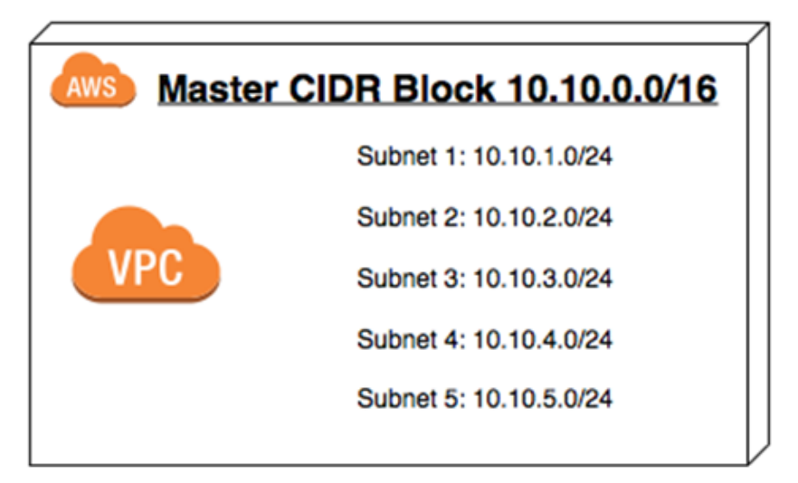
CIDR notation
CIDR notation represents an IP address and a suffix that indicates network identifier bits in a specified format. For example, you could express 192.168.1.0 with a 22-bit network identifier as 192.168.1.0/22.

Difference Between Classful Addressing and Classless Addressing
Parameter | Classful Addressing | Classless Addressing
Basics | In Classful addressing IP addresses are allocated according to the classes- A to E. | Classless addressing came to replace the classful addressing and to handle the issue of allocation of IP Address.
Network ID and Host ID | The changes in the Network ID and Host ID depend on the class. | There is no such restriction of class in classless addressing.
VLSM | It does not support the Variable Length Subnet Mask (VLSM). | It supports the Variable Length Subnet Mask (VLSM).
Bandwidth | Classful addressing requires more bandwidth. As a result, it becomes slower and more expensive as compared to classless addressing. | It requires less bandwidth. Thus, fast and less expensive as compared to classful addressing.
CIDR | It does not support Classless Inter-Domain Routing (CIDR). | It supports Classless Inter-Domain Routing (CIDR).
Updates | Regular or periodic updates | Triggered Updates
Troubleshooting and Problem detection | Troubleshooting and problem detection are easy than classless addressing because of the division of network, host and subnet parts in the address. | It is not as easy compared to classful addressing.
Division of Address | - Network  - Host  - Subnet | - Host  - Subnet

Below is a table providing typical subnets for IPv4.
Prefix size | Network mask | Usable hosts per subnet
/1 | 128.0.0.0 | 2,147,483,646
/2 | 192.0.0.0 | 1,073,741,822
/3 | 224.0.0.0 | 536,870,910
/4 | 240.0.0.0 | 268,435,454
/5 | 248.0.0.0 | 134,217,726
/6 | 252.0.0.0 | 67,108,862
/7 | 254.0.0.0 | 33,554,430
Class A
/8 | 255.0.0.0 | 16,777,214
/9 | 255.128.0.0 | 8,388,606
/10 | 255.192.0.0 | 4,194,302
/11 | 255.224.0.0 | 2,097,150
/12 | 255.240.0.0 | 1,048,574
/13 | 255.248.0.0 | 524,286
/14 | 255.252.0.0 | 262,142
/15 | 255.254.0.0 | 131,070
Class B
/16 | 255.255.0.0 | 65,534
/17 | 255.255.128.0 | 32,766
/18 | 255.255.192.0 | 16,382
/19 | 255.255.224.0 | 8,190
/20 | 255.255.240.0 | 4,094
/21 | 255.255.248.0 | 2,046
/22 | 255.255.252.0 | 1,022
/23 | 255.255.254.0 | 510
Class C
/24 | 255.255.255.0 | 254
/25 | 255.255.255.128 | 126
/26 | 255.255.255.192 | 62
/27 | 255.255.255.224 | 30
/28 | 255.255.255.240 | 14
/29 | 255.255.255.248 | 6
/30 | 255.255.255.252 | 2
/31 | 255.255.255.254 | 0
/32 | 255.255.255.255 | 0

Routing Tables in Computer Network
A Router is a networking device that forwards data packets between computer networks. This device is usually connected to two or more different networks. When a packet arrives at a router, it examines destination IP address of the received packet and makes routing decisions accordingly. Routers use Routing Tables to determine which interface the packet will be sent out. A routing table lists all networks for which routes are known. Each router’s routing table is unique and stored in the RAM of the device.
What is a Routing Table?
A routing table is a set of rules, often viewed in table format, that is used to determine where data packets traveling over an Internet Protocol (IP) network will be directed. All IP-enabled devices, including routers and switches, use routing tables. See below a Routing Table:
Destination | Subnet Mask | Interface
128.75.43.0 | 255.255.255.0 | Eth0
128.75.43.0 | 255.255.255.128 | Eth1
192.12.17.5 | 255.255.255.255 | Eth3
Default | 0.0.0.0 | Eth2

The entry corresponding to the default gateway configuration is a network destination of 0.0.0.0 with a network mask (netmask) of 0.0.0.0. The Subnet Mask of default route is always 0.0.0.0 .
Entries of an IP Routing Table
A routing table contains the information necessary to forward a packet along the best path toward its destination. Each packet contains information about its origin and destination. Routing Table provides the device with instructions for sending the packet to the next hop on its route across the network. Each entry in the routing table consists of the following entries:
- Network ID: The network ID or destination corresponding to the route.
- Subnet Mask: The mask that is used to match a destination IP address to the network ID.
- Next Hop: The IP address to which the packet is forwarded
- Outgoing Interface: Outgoing interface the packet should go out to reach the destination network.
- Metric: A common use of the metric is to indicate the minimum number of hops (routers crossed) to the network ID.
Routing table entries can be used to store the following types of routes:
- Directly Attached Network IDs
- Remote Network IDs
- Host Routes
- Default Route
- Destination
When a router receives a packet, it examines the destination IP address and looks up into its Routing Table to figure out which interface packet will be sent out.
How are Routing Tables Populated?
There are 3 ways to maintain Routing Table:
- Directly connected networks are added automatically
- Using Static Routing
- Using Dynamic Routing
These Routing tables can be maintained manually or dynamically. In dynamic routing, devices build and maintain their routing tables automatically by using routing protocols to exchange information about the surrounding network topology. Dynamic routing tables allow devices to "listen" to the network and respond to occurrences like device failures and network congestion. Tables for static network devices do not change unless a network administrator manually changes them.
Route Determination Process (Finding Subnet ID using Routing Table)
Consider a network is subnetted into 4 subnets as shown in the above picture. The IP Address of the 4 subnets are:
200.1.2.0 (Subnet a) 200.1.2.64 (Subnet b) 200.1.2.128 (Subnet c) 200.1.2.192 (Subnet d)
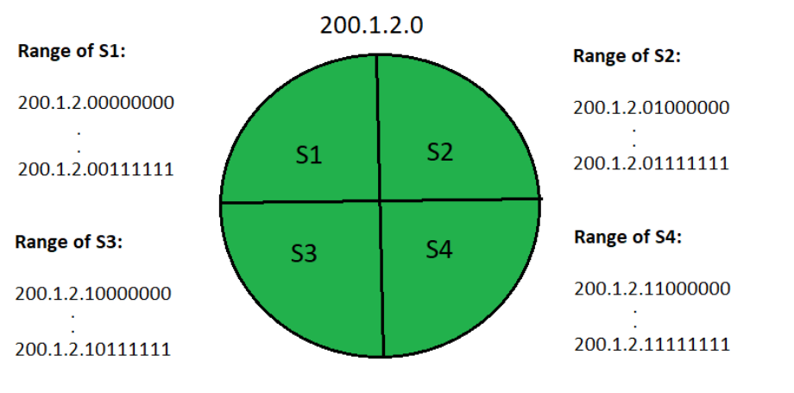

Then, Routing table maintained by the internal router looks like:
Destination | Subnet Mask | Interface
200.1.2.0 | 255.255.255.192 | a
200.1.2.64 | 255.255.255.192 | b
200.1.2.128 | 255.255.255.192 | c
200.1.2.192 | 255.255.255.192 | d
Default | 0.0.0.0 | e

To find its correct subnet (subnet ID), the router performs the bitwise ANDing of destination IP Address mentioned on the data packet and all the subnet masks one by one.
- If only one match occurs, the router forwards the data packet on the corresponding interface.
- If there are multiple matches, the router forwards the data packet on the interface corresponding to the longest subnet mask.
- If no match occurs, the router forwards the data packet to the interface corresponding to the default entry.

Router and Gateway
In the world of networking, there is a need to use devices such as Routers and Gateways that play a crucial role in facilitating communication between different networks. Although both Routers and Gateways can be used for connecting devices and networks, there are differences between them in terms of different layers of the networking model.
What is a Router?
A router is a networking device that forwards data packets between different computer networks. It connects multiple packet-switched networks or subnetworks, managing traffic by directing packets to their intended IP addresses. Routers allow multiple devices to share an Internet connection efficiently.
A Router is a device or hardware responsible for receiving, analyzing, and forwarding data packets to other networks. A router determines the destination or the target IP address of the packet and thus the best way to transfer the packet is determined by the help of forwarding tables and headers.
The forwarding of the data packet is done from one router to the other which forms a network (internet) until it reaches the final target node. A router is mainly used in the local area network (LAN) and wide area network (WAN) domain. The data is transferred across the network by using the routing protocols.
It is much more costly in comparison to other network devices like hubs, switches, etc. Some of the companies that develop routers are D-Link, Cisco, Nortel, etc.
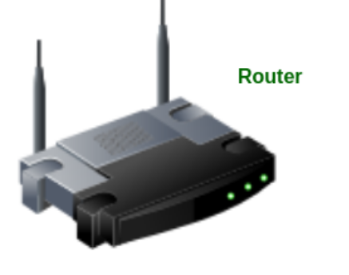
How Many Types of Routers are there?
There are different types of Routers present. We have to check the following list to understand different types of Routers.
- Wired Routers: Wired Routers are the most common ones where the Router is connected with one cable. Here, the Router is referred to as the Ethernet and is used to provide a high-speed connection.
- Wireless Routers: Another common Router is the Wireless Router. In this case, there is no cable needed to connect to the Internet. We can use the internet with the help of the WiFi Connections.
- Core Routers: Core Routers are highly used by the Internet Service Providers (ISPs). They are designed to work within the Core of the Internet. Core Routers used for high data traffic management.
- Edge Routers: The main intention of the Edge Router is to connect internal networks with external ones. To use the Internet with more security, the Edge router is very much important.
- Virtual Routers: From the name, we can understand there are Routers that are not present physically. In any software, the router works on any Virtual Machine. Virtual Routers are known for their Flexibility.
- Broadband Routers: These are the routers that can be used in the Home or Offices where the broadband services provide cable and with that cable the entire internet connection is established.
- Distribution Routers: If there are any large networks, then the Distribution Routers will be used. In this case, the Distribution Routers will take the data from different routers and pass them to the Core Routers.
Advantages and Disadvantages of a Router
Advantages of Router
- Data Routing Efficiency: Routers help to route data packets across networks based on their IP addresses.
- Supports Multiple Networks: Routers can easily support different types of networks like LAN and WAN.
- Enhanced Security: There are many routers that come with firewalls that help to increase security.
Disadvantages of Router
- Configuration Complexity: There is a big configurational complexity, which you will find when you will go for the setup Routers.
- Low Bandwidth: If there is more traffic coming to a single router, then it might provide low bandwidth.
- Latency Delay: You can notice Latency deals with the routers in the Network Communication for large amounts of data.

Gateway:
A network gateway is a hardware device or software solution that connects two discrete networks that use different transmission protocols. The gateway acts as the network entry-exit point and allows data to flow from one discrete network to another by translating communication protocols. Network gateway capabilities include enhanced security, intelligent routing, and IoT support with scalability to support a range of use cases spanning large enterprise campuses to small remote branch offices.
A gateway is a network connectivity device that connects two different configuration networks. Gateways are also known as protocol converters, because they play an important role in converting protocols supported by traffic on different networks. As a result, it allows smooth communication between two networks. It works as the entry-exit point for a network because all traffic that passes across the networks must pass through the gateway. A gateway monitors and controls all the incoming and outgoing network traffic. Gateways are also known as protocol converters In this article, we are going to discuss all important points related to Gateways.
A gateway is a network node or device that connects two networks that use different transmission protocols. Gateways play an important role in connecting two networks. It works as the entry-exit point for a network because all traffic that passes across the networks must pass through the gateway.
A gateway is a connecting point of any network that helps it to connect with different networks. The gateway monitors and controls all the incoming and outgoing traffic of the network. Suppose there are two different networks and they want to communicate with each other, so they need to set up a path between them. Now that path will be made between gateways of those different networks. Gateways are also known as protocol converters because they help to convert protocol supported by traffic of the different networks into that are supported by this network. Because of that, it makes smooth communication between two different networks.
Features of Gateways
Gateways provide a wide variety of features. Some of these are:
- A gateway is situated at a network edge and manages all data that enters or exits the network.
- A gateway is distinct from other network devices in that it can operate at any layer of the OSI model.
- Gateways made the transmission more feasible as it queued up all the data and divided it into small packets of data rather than sending it bulk.
- Gateways provide security within the network.

How Gateways Work?
- The gateway receives data from devices within the network.
- After receiving data the gateway intercept and analyze data packets, which include analyzing packet header, payload etc.
- Based on the analysis of the data packets, the gateway calculate an appropriate destination address of data packet. It then routes the data packets to their destination address.
- In some cases, the gateway might also want to transform the format of the obtained data to ensure compatibility at the receiver.
- Once the data packets have been analyzed, routed, and converted, then the gateway sends the last packets to their respective destinations address inside the network.
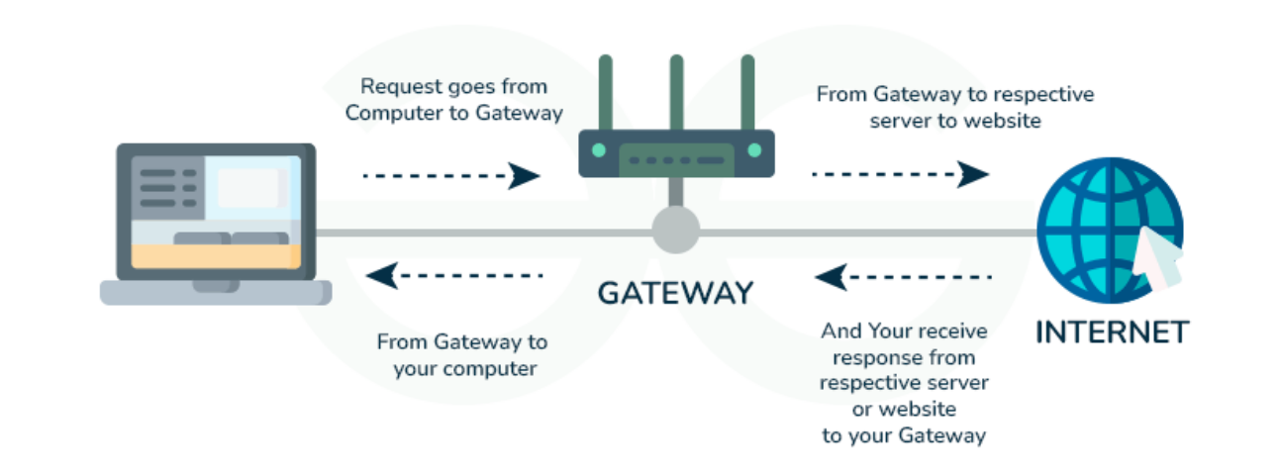

Functionality of Gateways
There are various functionalities that are supported by any gateway:
- LAN to WAN connections- It can connect a group of personal computers i.e. LAN(Local Area Network) to the Internet i.e. WAN(Wide Area Network).
- Controls incoming and outgoing data- It is located on the boundary of any network, so it controls incoming and outgoing data packets from/to any network.
- Works as a Protocol Converter- It makes sure that the data packet from another network is compatible with this network. So it converts their protocols into supported protocols and other stuff of the data packets before it enters into the network.
- Information Collector- It collects data from different sections of the network to make a better diagnosis of any data packets. In this process, it collects information.
- Routing of data packets- It is responsible for routing data packets to different networks because it knows about the routing path of different networks that are in communication with its network.

Different Types of Gateways
Gateways can be classified into multiple categories on different bases like on the basis of the direction of flow of data, functionality, etc...
On the Basis of the Direction of the Flow of Data
- Unidirectional Gateways: Unidirectional Gateway allows the flow of data in only one direction. It means the changes that occurred in the source can be copied to the destination but the changes that occurred in the destination can't be copied to the source.
- Bidirectional Gateways: Bidirectional Gateways allow the flow of data in both directions. It means changes that occurred in the source can be copied to the destination and changes that occurred in the destination can be copied to the source.
Based on Functionality
- Email Security Gateway: It scans email for any type of malicious content before allowing it to enter the network.
- Cloud Storage Gateway: It helps in data transfer between the cloud and the nodes of the network. It converts different API requests into that form which can be understandable by cloud platforms.
- Network Gateway: This is the most popular type of gateway, it acts as an interface between two different networks using different protocols.
- Internet-To-Orbit Gateway (I2O): Project HERMES and Global Educational Network for Satellite Operations (GENSO) are two well-known I₂O gateways that connect devices on the Internet to satellites and spacecraft orbiting the earth.
- IoT Gateway: Before delivering sensor data to the cloud network, IoT gateways assimilate it from Internet of Things (IoT) devices in the field and translate it between sensor protocols. They link user applications, cloud networks, and IoT devices.
- VoIP Trunk Gateway: By using a VoIP (voice over Internet Protocol) network, it makes data transmission between POTS (plain old telephone service) devices like landlines and fax machines easier.
Advantages of Gateways
- It helps in connecting two different networks.
- It filters and does not allow anything that can harm the network.
- It helps by doing protocol conversion.
- It provides security from external attacks.
Disadvantages of Gateways
- Its implementation is difficult and costly.
- It is hard to manage.
- It causes time delay because the conversion of data according to the network takes time.
- Failure of the gateway can cause the failure of connection with other networks.

Default gateway:
Routing is the most important process in networking. The process of routing includes various networking devices for packet forwarding one of which is the default gateway. The default gateway forwards the packets from the client to other network. This article is about a detailed description of the default gateway, its uses, and how it works in networking.
A default gateway is a network node—usually a router—that serves as the exit point for data traffic leaving a local network to connect with external networks, including the internet. It acts as the "default" route when a device does not know the specific path to a destination IP address outside its local subnet.
- The default gateway is the node that forwards the packet from the source to other networks when there is no routing information about the destination i.e. host (or router) does not know where the destination is present.
- A default gateway is a route to which information is passed when the device does not know where the destination is present.
- It is used when there is no routing information available about the destination.
- It is a node that allows the communication of computers on different networks.
- 'Default' here means the default route which is to be taken when the host does not know where the destination is.
- It is most commonly used for webpage access.
- This is an important part of networking for routing the data and finding the corresponding destination which is in another network.

When Default Gateway is Used:
When the source wants to reach a destination which is outside its network then, the source uses the default gateway to forward the data and locate the destination's network so that data should reach its intended destination. The default gateways are used when the host doesn't know about the destination's network i.e. the network in which the destination is present or when the route information is not available for any destination then it goes to the default gateway so that it can identify in which network the destination is and can forward the data through that route. The default gateway is an important device for the data forwarding and routing of the data on the other network. It helps in the communication of one network computer with the other network computer.
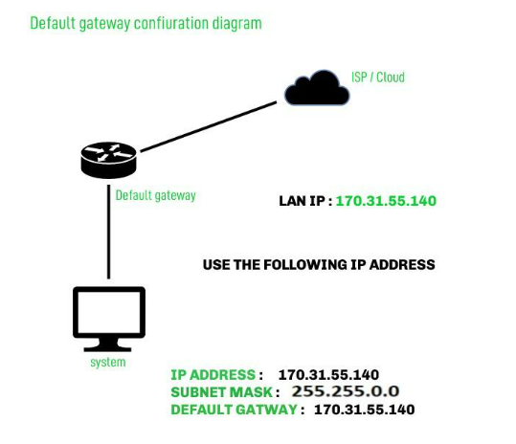
Key Takeaways of Default Gateway
- Exit Point: It's the essential exit point for local network traffic heading to external networks like the internet.
- Router's Role: Your router typically functions as your default gateway.
- IP Address: Every device needs to know its default gateway's IP address to communicate externally.
- Network Communication: Without it, local devices cannot access resources beyond their subnet.

How to Find Your Default Gateway:
1. In Windows:
- In Windows, we can get our default gateway with Command Prompt.
- To access the command prompt click on start and search for "CMD" and open.
- In the command prompt window type "ipconfig" command and press enter and you can see the Default Gateway in the information generated by the command with the machine's IP address listed.
2. In Linux:
- Open the terminal and use the command "ip route | grep default ". It will locate the default gateway.

Difference between Gateways and Router
Gateways | Router
A gateway is a device that is used for communication between networks having different sets of protocols. | Route is a device that receives, analyzes, and forwards the data packets to other networks.
Gateway connects two different networks. | It routes the data packets via the same networks.
Gateway does not support dynamic routing. | Router supports the dynamic routing.
The main function of a gateway is protocol translation. | The main function of a router is routing the traffic from one network to another network.
It is hosted on dedicated applications, physical servers, or virtual applications. | It is hosted on only the dedicated applications.
The gateway is also called a gateway router, proxy server, and voice gateway. | The router is also called a wireless router and an Internet router.

Protocol and Protocol number:
In networking, a protocol is a standardized set of rules for formatting and processing data. Protocols enable computers to communicate with one another.
A network protocol is a collection of rules that governs how data is transmitted, received, and interpreted between devices on a network, regardless of their internal structure or design. A protocol is simply a set of rules that devices follow to communicate.
- Defines what, how, and when data is communicated.
- Enables communication between heterogeneous devices.
- Ensures reliable and standardized data exchange.
- Prevents data loss, duplication, and misinterpretation.
How Do Network Protocols Work?
Network protocols work by dividing communication tasks into layers, where each layer performs a specific function to ensure successful data transmission.
- Communication is based on the OSI model, which consists of 7 layers.
- Each OSI layer uses specific protocols to perform its task.
- Data moves layer by layer from sender to receiver.
- Example: Internet Protocol (IP) operates at the Network Layer and handles routing using source and destination addresses.
- Layered communication improves reliability, scalability, and troubleshooting.
Types of Network Protocols
In most cases, communication across a network like the Internet uses the OSI model. The OSI model has a total of seven layers. Secured connections, network management, and network communication are the three main tasks that the network protocol performs. The purpose of protocols is to link different devices.
The protocols can be broadly classified into three major categories:
- Network Communication
- Network Management
- Network Security
A protocol number is a unique identifier used inside an IP packet to tell which protocol is carrying this data. It is present in the IP header. A protocol number is an 8-bit value in the IPv4 header (or "Next Header" field in IPv6) that identifies the specific transport layer protocol (such as TCP or UDP) used in an IP packet. Ranging from 0 to 255, these numbers allow network devices to identify the payload type, with common examples including 6 (TCP), 17 (UDP), and 1 (ICMP).
TCP:
Transmission Control Protocol (TCP) is a fundamental, connection-oriented transport layer protocol (Layer 4) ensuring reliable, ordered, and error-checked delivery of data packets between applications over IP networks. It establishes a connection via a three-way handshake before transmitting data, guaranteeing data integrity. TCP belongs to the Transport Layer (Layer 4 of the OSI model). TCP uses Protocol Number 6.
TCP (Transmission Control Protocol) is a protocol that allows devices to communicate reliably over a network. It ensures that data reaches the destination correctly and in the right order, even if parts of the network are slow or unreliable.
- It works at the Transport Layer (Layer 4) of the OSI model and is an essential part of the TCP/IP protocol suite used for Internet communication.
- TCP establishes a logical connection between the sender and receiver before data transmission begins.
- It ensures that data is delivered accurately and in the same order in which it was sent using acknowledgements and sequence numbers.
- TCP detects errors using checksums and retransmits lost or corrupted packets to maintain data integrity.
- It controls the data transmission rate to avoid overwhelming the receiver and adapts to network congestion for efficient communication.
TCP (Transmission Control Protocol): TCP is used when reliability and accuracy are important. It ensures that data is delivered exactly as sent.
- Error Checking: TCP detects errors in the data using checksums to ensure integrity.
- Retransmission: If any data is lost or corrupted during transmission, TCP automatically resends it.
- Ordered Delivery: Data is broken into packets, and TCP ensures these packets arrive in the correct sequence.
- Connection-Oriented: TCP establishes a connection between sender and receiver before sending data, maintaining a stable session throughout the communication.
- Use Cases: Loading web pages, downloading files, sending emails, or any application where data must be complete and accurate.

Connection Establishment and Termination
Connection establishment and termination describe how two devices start and end a reliable communication session (mainly in TCP).
1. Connection Establishment (Three-Way Handshake)
TCP is connection-orientated, meaning a connection must be established before any data is sent. This is done using a three-way handshake:
The TCP 3-Way Handshake is a process used by the Transmission Control Protocol (TCP) to establish a reliable connection between a client and a server before data transfer. It ensures that both sides are synchronized and ready to communicate.
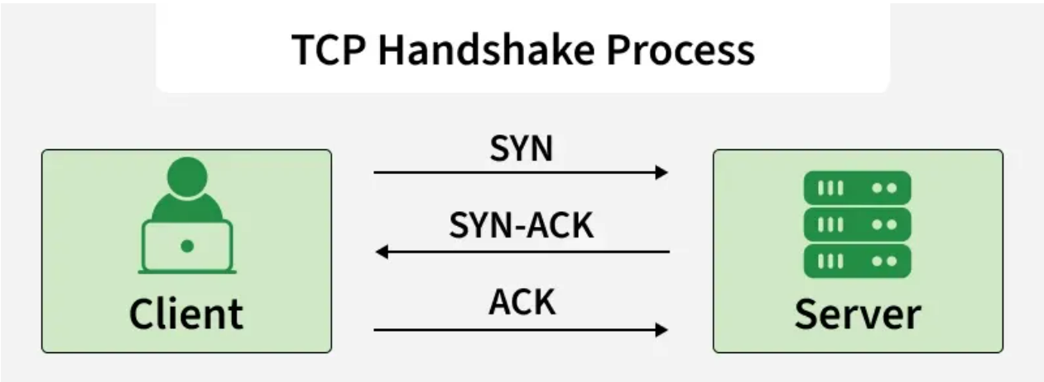
- SYN (Synchronize): The sender sends a SYN segment to the receiver to request a connection.
- SYN-ACK (Synchronize-Acknowledge): The receiver responds with a SYN-ACK segment, acknowledging the request and agreeing to the connection.
- ACK (Acknowledge): The sender replies with an ACK, confirming the connection is established.
Key Components & Purposes
- Purpose: Ensures reliable, connection-oriented communication at the transport layer, preventing data loss.
- Flags: SYN (Synchronize), ACK (Acknowledgment), FIN (Finish/Terminate).
- Sequence Numbers: Used to order packets and detect missing data.
- Result: A fully established, full-duplex (two-way) connection is opened, allowing for data transfer.
Once these three steps are complete, the connection is considered "established" and data transfer can begin. This process ensures both sender and receiver are ready and synchronized, preventing lost or mis ordered data at the start.

2. Connection Termination (Four-Way Handshake)
Closing a TCP connection requires a four-step handshake to ensure both sides finish transmitting data safely:
- FIN (Finish): The sender who wants to close the connection sends a FIN segment to the receiver.
- ACK (Acknowledge): The receiver acknowledges the FIN with an ACK.
- FIN (Finish) from Receiver: The receiver then sends its own FIN when it is ready to close the connection.
- ACK (Acknowledge): The sender responds with an ACK, completing the termination.
This ensures that all remaining data is transmitted before the connection is fully closed.
Advantages
- Error-Free Data Transfer: TCP detects errors during transmission and retransmits lost or corrupted data, ensuring accurate delivery.
- Ordered Delivery: Data packets are received in the same sequence in which they were sent, maintaining data consistency.
- Flow Control: Prevents the sender from overwhelming the receiver by controlling the rate of data transmission.
- Congestion Control: Adjusts the sending speed based on network traffic conditions to reduce packet loss and congestion.
- Reliable Communication: Ensures complete and dependable data transfer, making it suitable for critical applications.
- Widely Supported and Standardized: TCP is a globally accepted protocol, supported by all major operating systems and network devices.

UDP:
User Datagram Protocol (UDP) is a lightweight, connectionless transport layer protocol designed for high-speed communication. Unlike TCP, UDP prioritizes speed over reliability by eliminating handshakes, error correction, and acknowledgment of data reception, making it ideal for real-time applications like VoIP, online gaming, and video streaming. UDP belongs to the Transport Layer (Layer 4 of the OSI model). UDP uses Protocol Number 17.
User Datagram Protocol (UDP) is a Transport Layer protocol of the Internet Protocol (IP) that provides fast, connectionless, and lightweight communication between processes. It does not guarantee delivery, order, or error checking, making it suitable for real-time and time-sensitive applications such as video streaming, DNS, and VoIP.
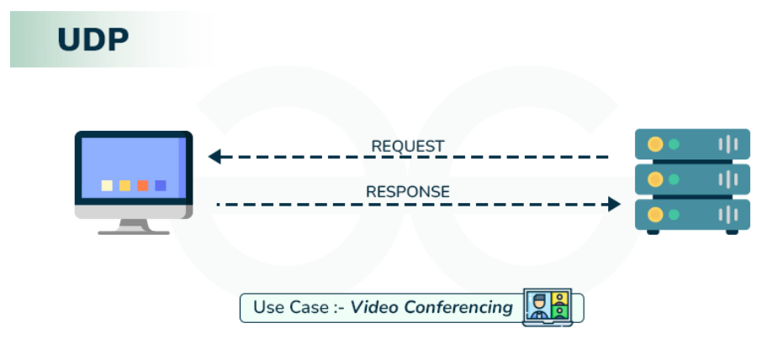
UDP (User Datagram Protocol): UDP is used when speed is more important than perfect accuracy. It is faster but does not guarantee reliable delivery.
- No Error Checking: UDP does not verify whether the data has errors.
- No Retransmission: Lost or damaged data is not resent. Does not ensure packet ordering or retransmission, making it suitable for scenarios that can tolerate minor data loss.
- No Ordered Delivery: Packets may arrive out of order, and the protocol does not fix it.
- Low Latency: Ideal for time-sensitive tasks where speed matters more than occasional data loss.
- Lightweight: Because it avoids extra checks and connections, UDP is faster and uses fewer resources. Minimal overhead (8-byte header) compared to TCP.
- Connectionless: No initial connection (handshake) is established, which saves time, though it does not guarantee delivery.
- Use Cases: Live video streaming, online gaming, VoIP calls, or real-time applications where speed matters more than reliability.
Common Use Cases:
- Real-time Streaming: Video and audio streaming where delays are more disruptive than missing frames.
- Gaming: Online gaming requires fast communication, allowing lost packets to be overlooked.
- VoIP (Voice over IP): Voice services prefer low latency over perfect data accuracy.
- DNS (Domain Name System): DNS lookups need quick, efficient responses.
- Broadcasting/Multicasting: Efficient for sending data to multiple recipients.
UDP Header
UDP header is 8 bytes long, followed by the data payload. It contains all the essential information needed for transmission. Each port number field is 16 bits, giving a range from 0 to 65535, where port 0 is reserved. Port numbers are used to identify and separate different user requests or processes.
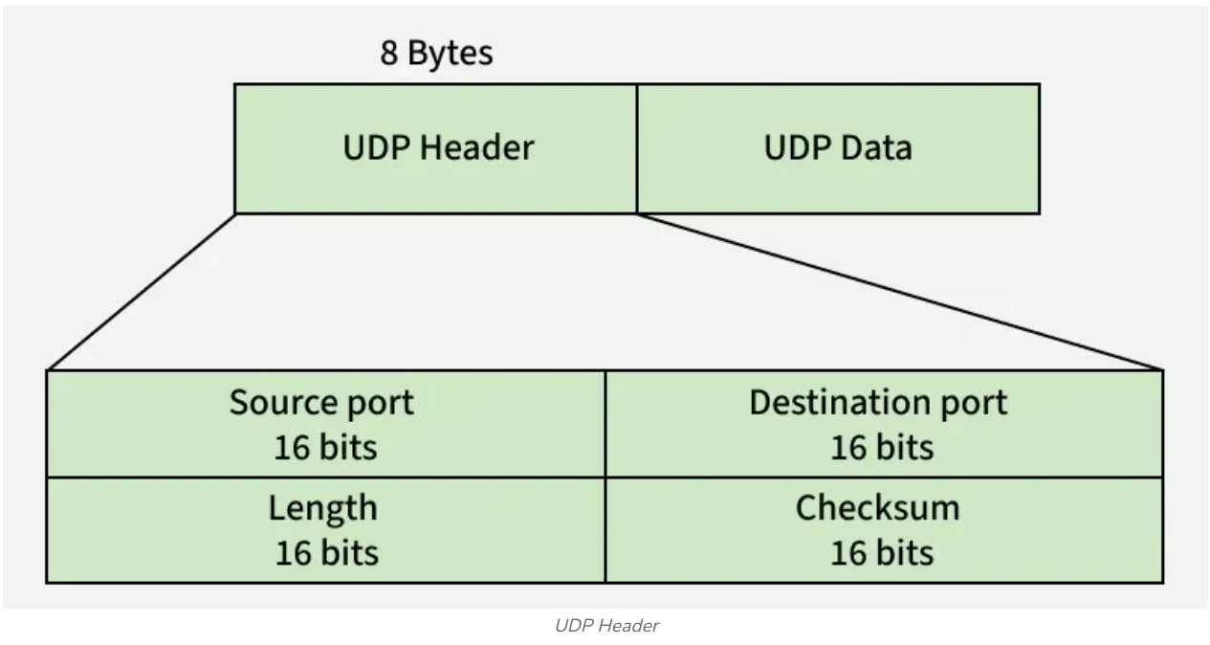
Field | Size | Description
Source Port | 16 bits | Identifies the sender’s port number.
Destination Port | 16 bits | Identifies the receiver’s port number.
Length | 16 bits | Specifies the total length of UDP header and data.
Checksum | 16 bits | Used for error detection (optional in IPv4, mandatory in IPv6).

Notes: Unlike TCP, checksum in UDP is optional, it provides no error or flow control, relying on IP/ICMP for error reporting, while port numbers help differentiate user requests.

Applications of UDP
UDP is preferred where low latency is crucial and occasional packet loss is acceptable:
- DNS uses UDP for fast query/response lookups since domain name queries are small and need quick replies.
- DHCP uses UDP to dynamically assign IP addresses to devices, where small control messages are exchanged.
- VoIP uses UDP for real-time voice communication, as it tolerates some packet loss but not delays.
- RIP uses UDP to send periodic routing updates between routers efficiently.
- NTP uses UDP to synchronize system clocks across networks with minimal overhead.

TCP Vs UDP
TCP (Transmission Control Protocol) and UDP (User Datagram Protocol) are two core protocols of the Transport Layer of the OSI and TCP/IP models. Both are responsible for end-to-end communication between applications, but they differ significantly in terms of reliability, speed, and use cases. Understanding the difference between TCP and UDP is essential for designing efficient and reliable networked systems. UDP is faster but less reliable than TCP. In a TCP communication, the two computers begin by establishing a connection via an automated process called a ‘handshake.’ Only once this handshake has been completed will one computer actually transfer data packets to the other. UDP communications do not go through this process. Instead, one computer can simply begin sending data to the other
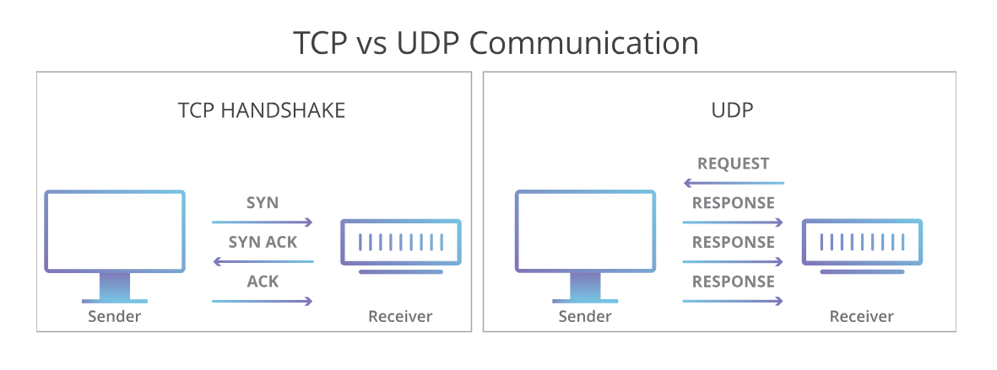
Transmission Control Protocol (TCP)
TCP is a reliable, connection-oriented transport protocol that ensures accurate and ordered data delivery. It uses control mechanisms to guarantee data correctness, which makes it slower but dependable.
- Connection-oriented protocol
- Reliable and ordered data delivery
- Higher overhead but high accuracy

User Datagram Protocol (UDP)
UDP is a fast, connectionless transport protocol that sends data without reliability guarantees. It is efficient for applications where speed is more important than accuracy.
- Connectionless and lightweight
- No guarantee of delivery or order
- Low overhead and high speed

TCP (Transmission Control Protocol) | UDP (User Datagram Protocol)
Connection-oriented; uses a three-way handshake | Connectionless; no handshake
Guarantees reliable data delivery | Does not guarantee delivery
Uses acknowledgements (ACKs) | No acknowledgements
Supports retransmission of lost packets | No retransmission support
Ensures packets are delivered in order | Does not ensure ordering
Provides flow control and congestion control | No flow or congestion control
Slower due to higher overhead | Faster with minimal overhead
Variable header size (20–60 bytes) | Fixed header size (8 bytes)
Treats data as a continuous byte stream | Treats data as independent messages
Does not support broadcasting or multicasting | Supports broadcasting and multicasting
Used by HTTP, HTTPS, FTP, SMTP | Used by DNS, DHCP, VoIP, Streaming

Networking Commands
ping: Ping (Packet Internet Groper) is a basic Internet command used in computer network administration to test and verify the availability of a destination IP address. It helps users confirm whether the computer they are trying to reach is operational. Ping works by measuring the communication latency which is the time taken for data to travel between two devices or across a network. As communication latency decreases, the effectiveness of communication improves and hence makes it an essential tool for network troubleshooting. It can be used with any operating system (OS) that supports networking.
Ping is important in situations where low latency is required or when speed is more important than the quantity and quality of the information as a low ping time ensures timely delivery of data. Network administrators rely on Ping to track device availability, diagnose network issues, and identify connectivity or latency problems.
The ping command usually sends multiple ICMP echo requests to a remote hosts (network hosts) to assess its availability and responsiveness. It's a useful tool for checking network connectivity and diagnosing network issues.
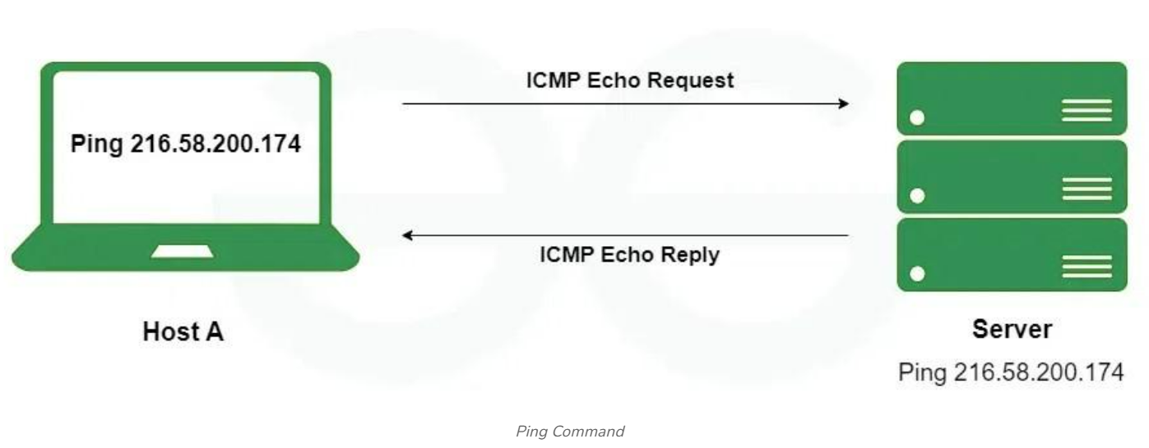
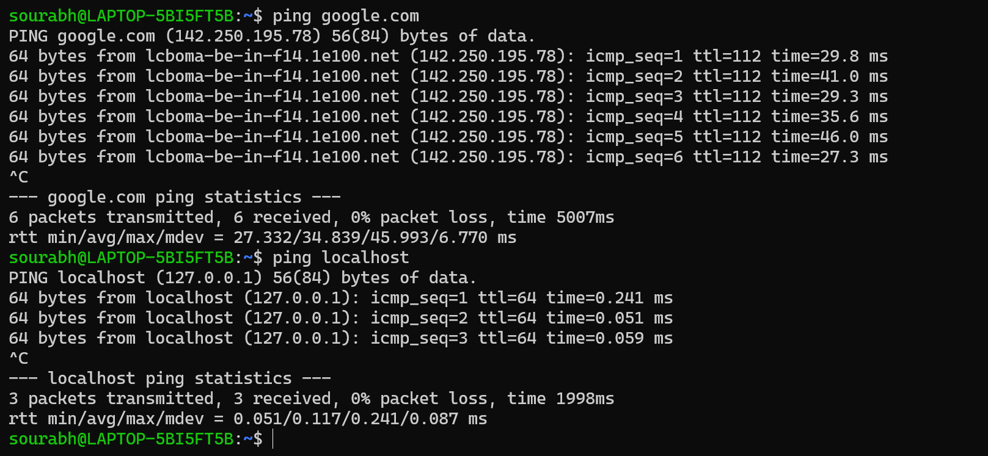

nslookup: Nslookup (stands for “Name Server Lookup”) is a useful command for getting information from the DNS server. It is a network administration tool for querying the Domain Name System (DNS) to obtain domain name or IP address mapping or any other specific DNS record. It is also used to troubleshoot DNS-related problems.
iptables: The iptables command in Linux is a powerful tool that is used for managing the firewall rules and network traffic. It facilitates allowing the administrators to configure rules that help how packets are filtered, translated, or forwarded. On using this iptables, you can set up security policies to control incoming and outgoing traffic, define port forwarding, and implement network address translation (NAT). It's essential for securing servers and networks by selectively permitting or denying specific types of traffic based on defined rules and conditions. This flexibility makes iptables a fundamental component in Linux networking and security configurations.
iptables is a command-line user-space utility in Linux that configures the Netfilter kernel firewall, allowing administrators to define rules for filtering, managing, and NATing IPv4 network traffic. It uses a table-based structure (default: filter) with chains (INPUT, OUTPUT, FORWARD) to accept, drop, or reject packets.
It is a command line interface used to set up and maintain tables for the Netfilter firewall for IPv4, included in the Linux kernel. The firewall matches packets with rules defined in these tables and then takes the specified action on a possible match.
- Tables is the name for a set of chains.
- Chain is a collection of rules.
- Rule is condition used to match packet.
- Target is action taken when a possible rule matches. Examples of the target are ACCEPT, DROP, QUEUE.
- Policy is the default action taken in case of no match with the inbuilt chains and can be ACCEPT or DROP.

Router:

Dynamic Host Configuration Protocol (DHCP)
DHCP is a network protocol that automatically gives devices an IP address and other network settings so they can connect and communicate on a network without manual configuration.
- Assigns a unique IP address to each device.
- Provides the subnet mask to define the local network range.
- Configures the default gateway for communication outside the local network.
- Supplies DNS server addresses for domain name resolution.
Dynamic Host Configuration Protocol (DHCP) is a network management protocol that automatically assigns IP addresses, subnet masks, default gateways, and DNS servers to devices (clients). It eliminates manual network configuration, preventing IP conflicts and simplifying network administration for both small and large networks.

